**EXTRACTION AND ANALYSIS OF SARCOIDOSIS ILD PATTERN FROM LUNG CT IMAGE**

***A project report submitted to***

#### JAWAHARLAL NEHRU TECHNOLOGICAL UNIVERSITY ANANTAPUR, ANANTHAPURAMU

*in partial fulfillment of the requirements for the award of degree of*

**BACHELOR OF TECHNOLOGY**

### in

**ELECTRONICS AND COMMUNICATION ENGINEERING**

***Submitted by***

#### A. KOWSHIK KUMAR - 18121A0407

**A. VENKATESH - 18121A0404**

#### A. TAGORE SIVA SAI - 18121A0402 E. SUMANTH KUMAR - 18121A0449

***Under the Guidance of***

#### Dr. V. VIJAYA KISHORE, M.Tech., Ph.D.

Professor, Dept. of ECE



## Department of Electronics and Communication Engineering

**SREE VIDYANIKETHAN ENGINEERING COLLEGE**

#### (AUTONOMOUS)

Sree Sainath Nagar, A. Rangampet , Tirupathi – 517102.

# **(2018-2022)**

**SR****EE** **VIDYANIKETHAN ENGINEERING COLLEGE**

**(AUTONOMOUS)**

SreeSainath Nagar, A.Rangampet - 517 102

**VISION**

To be one of the Nation’s premier Engineering Colleges by achieving the highest order of excellence in Teaching and Research.

**MISSION**

* To foster intellectual curiosity, pursuit and dissemination of knowledge.
* To explore students’ potential through academic freedom and integrity.
* To promote technical mastery and nurture skilled professionals to face competition in ever increasing complex world.

#### QUALITY POLICY

Sree Vidyanikethan Engineering College strives to establish a system of Quality Assurance to continuously address, monitor and evaluate the quality of education offered to students, thus promoting effective teaching processes for the benefit of students and making the College a Centre of Excellence for Engineering and Technological studies.

**DEPARTMENT OF ELECTRONICS AND COMMUNICATION ENGINEERING**

**Vision**

To be a center of excellence in Electronics and Communication Engineering through teaching and research producing high quality engineering professionals with values and ethics to meet local and global demands.

**Mission**

* + The Department of Electronics and Communication Engineering is established with the cause of creating competent professionals to work in multicultural and multidisciplinary environments.
  + Imparting knowledge through contemporary curriculum and striving for development of students with diverse background.
  + Inspiring students and faculty members for innovative research through constant interaction with research organizations and industry to meet societal needs.
  + Developing skills for enhancing employability of students through comprehensive training process.
  + Imbibing ethics and values in students for effective engineering practice.

**B.Tech. (Electronics and Communication Engineering)**

**Program Educational Objectives**

After few years of graduation, the graduates of B.Tech (ECE) will be:

|  |  |
| --- | --- |
| **PEO1.** | Enrolled or completed higher education in the core or allied areas of electronics and  communication engineering or management. |
| **PEO2.** | Successful entrepreneurial or technical career in the core or allied areas of electronics  and communication engineering. |
| **PEO3.** | Continued to learn and to adapt to the world of constantly evolving technologies in the  core or allied areas of electronics and communication engineering. |

**Program Outcomes**

On successful completion of the Program, the graduates of B.Tech. (ECE) Program will be able to:

|  |  |
| --- | --- |
| **PO1** | **Engineering knowledge**: Apply the knowledge of mathematics, science, engineering  fundamentals, and an engineering specialization to the solution of complex engineering problems. |
| **PO2** | **Problem analysis**: Identify, formulate, research literature, and analyze complex  engineering problems reaching substantiated conclusions using first principles of mathematics, natural sciences, and engineering sciences. |
| **PO3** | **Design/development of solutions**: Design solutions for complex engineering problems and design system components or processes that meet the specified needs with appropriate  consideration for the public health and safety, and the cultural, societal, and environmental considerations. |
| **PO4** | **Conduct investigations of complex problems**: Use research-based knowledge and  research methods including design of experiments, analysis and interpretation of data, and synthesis of the information to provide valid conclusions. |
| **PO5** | **Modern tool usage**: Create, select, and apply appropriate techniques, resources, and  modern engineering and IT tools including prediction and modeling to complex engineering activities with an understanding of the limitations. |
| **PO6** | **The engineer and society**: Apply reasoning informed by the contextual knowledge to  assess societal, health, safety, legal and cultural issues and the consequent responsibilities relevant to the professional engineering practice. |
| **PO7** | **Environment and sustainability**: Understand the impact of the professional  engineering solutions in societal and environmental contexts, and demonstrate the knowledge of, and need for sustainable development. |
| **PO8** | **Ethics**: Apply ethical principles and commit to professional ethics and responsibilities and norms of the engineering practice. |
| **PO9** | **Individual and team work**: Function effectively as an individual, and as a member or leader in diverse teams, and in multidisciplinary settings. |
| **PO10** | **Communication**: Communicate effectively on complex engineering activities with the engineering community and with society at large, such as, being able to comprehend and  write effective reports and design documentation, make effective presentations, and give and receive clear instructions. |
| **PO11** | **Project management and finance**: Demonstrate knowledge and understanding of the  engineering and management principles and apply these to one’s own work, as a member and leader in a team, to manage projects and in multidisciplinary environments. |
| **PO12** | **Lifelong learning**: Recognize the need for, and have the preparation and ability to engage in independent and life-long learning in the broadest context of technological change. |

**Program Specific Outcomes**

*On successful completion of the Program, the graduates of B. Tech. (ECE) will be able to*

|  |  |
| --- | --- |
| **PSO1.** | Apply the knowledge of Electronics, Signal Processing, Communications, and VLSI & Embedded Systems to the solutions of real world problems. |
| **PSO2.** | Analyze, Design and Develop solutions in real time in the domains of Electronics, Signal Processing, Communications, and VLSI & Embedded Systems. |
| **PSO3.** | Conduct investigations and address complex engineering problems in the domains of Electronics, Signal Processing, Communications, and VLSI & Embedded Systems. |
| **PSO4.** | Apply appropriate techniques, resources, and modern tools to complex engineering systems and processes in the domains of Electronics, Signal Processing,  Communications, and VLSI & Embedded Systems. |

**Department of Electronics and Communication Engineering**

# SREE VIDYANIKETHAN ENGINEERING COLLEGE

#### (AUTONOMOUS)

Sree Sainath Nagar, A. Rangampet, Tirupathi - 517102.

Certificate

*This is to certify that the project report entitled*

**“Extraction and Analysis of Sarcoidosis ILD Pattern from Lung CT Image”**

*is the bonafide work done and submitted by*

#### A. KOWSHIK KUMAR - 18121A0407

**A. VENKATESH - 18121A0404**

#### A. TAGORE SIVA SAI - 18121A0402 E. SUMANTH KUMAR - 18121A0449

*in the Department of Electronics and Communication Engineering,* ***Sree Vidyanikethan Engineering College*,** *A.Rangampet, affiliated to* **Jawaharlal Nehru Technological University Anantapur, Ananthapuramu** *in partial fulfillment of the requirements for the award of the degree of* **Bachelor of Technology** *in* **Electronics and Communication Engineering** *during 2018-2022.*

**GUIDE HOD**

**Dr. V. VIJAYA KISHORE, M.Tech., Ph.D. Dr. N. GIREESH, M.Tech., Ph.D.**

Professor, Dept. of ECE Professor & Head, Dept. of ECE.

**INTERNAL EXAMINER EXTERNAL EXAMINER**

## ACKNOWLEDGEMENT

First of all, we are indebted to the GOD ALMIGHTY for giving us an opportunity to excel in our efforts to complete this project on time.

Our heartfelt gratitude to our seminar guide **Dr. V. Vijaya Kishore ,** Professor of ECE, Electronics and Communication, for his valuable suggestions and guidance in the preparation of the Project Thesis.

We express our heartfelt thanks to **Dr. N Gireesh**, Professor and Head, Department of Electronics and Communication Engineering, for his kind attention and valuable guidance to us throughout the Project Course.

We owe our gratitude to **Dr. B. M. Sathish**, Principal, Sree Vidyanikethan Engineering College for permitting us to use the facilities available to accomplish the Project course.

We are also thankful to all the teaching and non-teaching staff of Electronics and Communication Engineering Department for their cooperation.

**A. KOWSHIK KUMAR**

**A. VENKATESH**

**A. TAGORE SIVA SAI**

**E. SUMANTH KUMAR**

## ABSTRACT

Morphological changes are often associated with unwanted growth of tissues. Identifying and quantifying these changes have always used as first line of diagnosis. Most of the clinicians expressed cumbersome due to enormous amount of medical images and also poor quality of images during acquisition, limiting the correct diagnosis. Large range of lung patterns of disease can be observed from CT scan images. For clinical practices, images are accumulated and stored in digital representation from MRI, CT, Ultrasound etc., in PACS, processing and thereby for diagnosis. Medical image segmentation is an important step form resuccessive image analysis tasks. The goal of lung segmentation is to separate region of interest (ROI) for extracting lung abnormalities of Interstitial Lung Disease (ILD) patterns like Sarcoidosis, Idiopathic pulmonary fibrosis, Malignant nodules, and Sarcoidosis structures. These ROI’s are affected by background regions and exhibit various levels of quality and brightness. In this project morphology-based segmentation is used to extract sarcoidosis patterns that are used for diagnosis and prognosis of pulmonary disease. The performance of the proposed method is evaluated in noisy environment. Salt and pepper noise, Speckle noise, Poisson noise, Gaussian noise are added to original image for the evaluation of noise effect. Comparison is implemented between patterns from noisy and noiseless images. Noise reduction capabilities of proposed method on a particular noise type is validated based on correlation co-efficient and peak Signal-to-Noiseratio. In this project a GUI is designed to perform Morphology based segmentation to extract Sarcoidosis pattern.

|  |  |  |
| --- | --- | --- |
|  | **TABLE OF CONTENTS** |  |
| **CHAPTER NO** | **TOPICS** | **PAGENO** |
|  | **ACKNOWLEDGEMENT**  **ABSTRACT** | **vi**  **vii** |
|  | **ABBREVATIONS LIST OF FIGURES** | **x iii-iv** |
| **CHAPTER1** | **INTRODUCTION** | **1-6** |
| **CHAPTER2** | **BIOMEDICALIMAGE PROCESSING** | **7-19** |
|  | 2.1 Introduction | 7 |
|  | 2.2 Steps of Image Processing | 7 |
|  | 2.3 Biomedical Image Processing | 8 |
|  | 2.4 Medical Image Formation | 9 |
|  | 2.5 Computed Tomography | 10 |
|  | 2.5.1 History of CT | 10 |
|  | 2.5.2 Sequential CT | 10 |
|  | 2.5.3 Spiral CT | 10 |
|  | 2.6 Working of CT Scanner | 12 |
|  | 2.7 What Does A CT Scanner Show? | 14 |
|  | 2.8 Windowing | 15 |
|  | 2.9 CT In General Clinical Use | 15 |
|  | 2.9.1 Advantages of Spiral CT in Clinical Use | 16 |
|  | 2.9.2 CT Angiography(CTA) | 16 |
|  | 2.9.3 CT Scanning Advantages | 16 |
|  | 2.9.4 Disadvantages | 16 |
|  | 2.9.5 Common Medical Applications | 16 |
|  | 2.9.6 Challenges in Medical Image Processing  2.10 DICOM  2.11 DICOM in Radiology | 17  17  17 |

|  |  |  |
| --- | --- | --- |
| **CHAPTER3** | **SEGMENTATION** | **18-29** |
|  | 3.1 Image Segmentation  3.1.1 Edge Based Segmentation  3.1.2 Region Based Segmentation | 19  20  21 |

3.2 Detection of Discontinuities 22

* + 1. Edge Detection for Image Segmentation 23
  1. Classification of Edge Detectors 24
  2. Morphological Operations 25
     1. Basic Operations in Morphology 26
     2. Morphological gradient 27
  3. Advantages and Disadvantages of Edge Detectors 28
  4. Morphological Reconstruction 29
  5. Medical Image Segmentation 29

|  |  |  |
| --- | --- | --- |
| **CHAPTER 4** | **METHODOLOGY AND** | **30** |
|  | **IMPLEMENTATION** |  |
|  | 4.1 Requirements | 30 |
|  | 4.2 Methodology | 31 |
| **CHAPTER 5** | **GRAHICAL USER INTERFACE** | **32** |
|  | * 1. Guide      1. The Layout Editor      2. Edit text      3. Axes      4. Push button      5. Popup menu | 32  33  33  33  34  34 |
|  | 5.2 Development of GUI | 35-38 |
| **CHAPTER7** | **RESULTS AND DISCUSSIONS** | **38-43** |
| **CHAPTER8** | **CONCLUSION ANDFUTURE SCOPE** | **44** |

**REFERENCE 45**

**ANNEXURE MATLAB PROGRAM**

|  |  |  |
| --- | --- | --- |
|  |  | **ABBREVIATIONS** |
| 1 | CT | Computed Tomography |
| 2 | CAT | Computed Axial Tomography |
| 3 | PET | Positron Emission Tomography |
| 4 | US | Ultrasound Scanning |
| 5 | ILD | Interstitial Lung Disease |
| 6 | IPF | Idiopathic Pulmonary Fibrosis |
| 7 | HRCT | High Resolution Computed Tomography |
| 8 | DICOM | Digital Imaging and Communication in Medicine |

## LIST OF FIGURES

### S No Fig No Label of the Figure Page No

2

|  |  |  |
| --- | --- | --- |
| 1 | 1.1 | Classification of ILD |
| 2 | 1.2 | a) Pulmonary Lung Nodule Causing Cancer  b) Lung Nodules in 3DDisplay  c) Mass |
| 3 | 1.3 | a) Sarcoidosis Lung  b) End Stage of Honey Comb Lung Model  c) End Stage Honey Comb Lung |
|  |  |
|  |  |
| 4 | 1.4 | a) Sarcoidosis |
|  |  | b) Sarcoidosis Lung |
|  |  | c) Sarcoidosis Lung in 3D |
|  |  | d) Severe Sarcoidosis |
| 5 | 1.5 | a) IPF Lung |
|  |  | b) IPF 3D Lung |
|  |  | c) IPF Lung Slice |
| 6 | 2.1 | Modules of image Processing |
| 7 | 2.2 | Medical imaging Modalities |
| 8 | 2.3 | Sequential CT |
| 9 | 2.4 | Spiral CT |

3

3

3

4

4

4

5

5

5

5

5

5

5

8

9

11

11

12

|  |  |  |
| --- | --- | --- |
| 10 | 2.5 | CT Scan Machine- APhilips64slice'Brilliance' Scanner |
| 11 | 2.6 | Various Scan of Different Angles |

13

14

|  |  |  |
| --- | --- | --- |
| 12 | 2.7 | Conversion of Scanned into Medical Image |
| 13 | 2.8 | Windowing Process |
| 14 | 2.9 | Major Picturing Archiving and Communication system Components |
| 15 | 3.1 | Types of Segmentation and their Principles |
| 16 | 3.2 | 3*3 General Mask and gray Levels |
| 17 | 3.3 | 1. Gray level profile of an image 2. First Order Derivative of the Profile |
| 20 | 3.4 | c) Second Order Derivative of the Profile Gradient of image |

15

18

21

22

24

24

24

28

|  |  |  |  |
| --- | --- | --- | --- |
| 21 | 3.5 | Successive Dilations of Marker, Constrained by Mask | 30 |
| 22 | 5.1 | GUIDE Quick start dialog | 33 |
| 23 | 5.2 | GUI Layout Editor | 34 |
| 24 | 5.3 | Static Text | 34 |
| 25 | 5.4 | Axes | 35 |
| 26 | 5.5 | Adding Push Button | 35 |
| 27 | 5.6 | Adding Pop-up Menu | 36 |
| 28 | 5.7 | GUI Output Interface Template | 36 |
| 29 | 5.8 | Original Image | 37 |
| 30 | 5.9 | Original Segmented Image | 37 |
| 31 | 5.10 | Original ROI | 38 |
| 32 | 5.11 | Abnormalities | 38 |
| 33 | 6.1 | Resultant intermediate images of Sarcoidosis pattern extraction | 39 |
| 34 | 6.2 | Segmented ROI and directional details of Sarcoidosis Pattern | 40 |
| 35 | 6.3 | lesson details (nodules detected by ROI) of Sarcoidosis Pattern | 41 |
| 36 | 6.4 | Resultant Intermediate images | 42 |

### INTRODUCTION

The area of medical imaging has developed into a significant scientific discipline. The examination of patient data is gained by image modalities such as CT, MRT, PET and US. Those imaging methods propose unachieved advancements for diagnosis and therapy evaluation. Medical image processing is necessary to influence increasing aggregation of scientific information and to examine information for specific medical objective. Medical image analysis needs image processing techniques and pre-processing functions like noise removal, image enhancement and edge detection. Feature extraction is executed to acknowledge the ROI which may be tumor, lesion or abnormality. For suspicious connected parts in the image, abnormal colors and appearance are to be physically differentiated by radiologists for advanced observations. For further processing of medical imaging, particular methods to full fill image segmentation are sorted with separate assortative biomedical application. The main intention of medical image processing is to provide valued representation of the contents. Computed Tomography is more likely known as computed axial tomography or CAT scan is a principle that assists X rays (radiographs) and computers (for computations) to generate three-dimensional likeliness of the human body. Other than methods using photographic films that signify opaque physical organs like bones, CT stipulates thorough range of the contrast tissues, such as lymph’s, muscle tissue for fluid pumping and body parts like lungs. CT images render a physical representation which assists in identifying distinct pneumonic diseases like ILD and also tumors. Several pulmonic diseases can be determined by studying the lung tissue patterns of pulmonary CT images. So, segmentation of lung is a primitive operation to acquire texture extraction and analysis. ILDsaremorethan200different types which are heterogeneous group of parenchymal lung disorders due to alveolar septal thickening, fibroblast proliferation, collagen decomposition and pulmonary fibrosis. Majority of ILDs are due to unknown causes Known causes may be inhaling organic or inorganic dusts, gases, fumes, drugs, radiation and smoking infections. ILDs are classified into acute, chronic and episodic. Acute ILDs are because of infection, allergy or toxins. Chronic ILDs are caused by drug side effects and most common are cancer, IPF sarcoidosis and honey combing. A pulmonary lung nodule is any space occupying lesion either solitary or multiple on the lung that is 3cm in diameter or less and if larger considered as Lung mass, are cancerous. Malignancy of lung nodules in elder people seems to be more cancerous and serious issue for mortality.

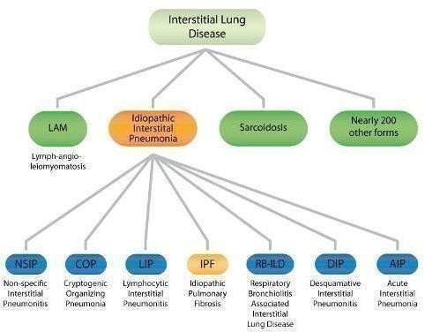

**Fig***.*1.1: Classification of ILD

Nodules have dissimilar aspects round, flat or speculate appearing on the edge regions. Classification of ILDs is shown in Fig 1.1 Different types of ILDs for lung nodules are shown in Fig 1.2(a), 1.2(b) & 1.2(c). Interstitial Lung Disease (ILD) is not a lung disease itself but a group of several lungs including Idiopathic Pulmonary Fibrosis (IPF). You can see the difference between IPF and other interstitial lung diseases by looking at the affected lung tissue and under a microscopic. According to WebMD, ILD attack the interstitial, the tissue and space around the lung’s airsacs. A pulmonary nodule is a small round or oval-shaped growth in the lung. It may also be called a “spot on the lung” or a “coin lesion.” Pulmonary nodules are smaller than three centimeters (around 1.2 inches) in diameter. If the growth is larger than that, it is called a pulmonary mass and is more likely to represent a cancer than a nodule. Countless pulmonary nodules are discovered each year during chest X-rays or CT scans. CT scan imaging is best imaging technique in medical field, it is difficult for doctors to interpret and identify the cancer from CT scan images. Therefore, computer aided diagnosis can be helpful for doctors to identify the cancerous cells accurately. Many computers aided techniques using image processing and machine learning has been researched and implemented.

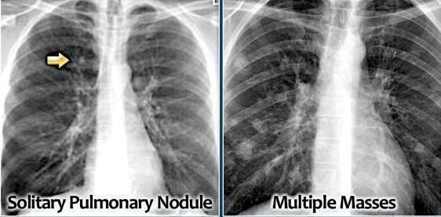

(a)

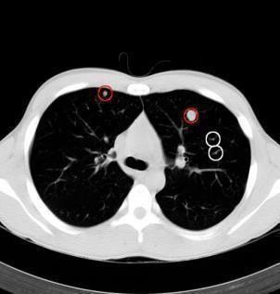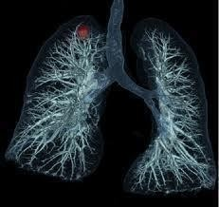

(b) (c)

**Fig.**1.2. (a): Pulmonary lung nodules causing cancer*.* (b) Lung nodules in 3D display*.* (c)Mass.

Magnetic Resonance Imaging (MRI) of the lungs an evolving, powerful tool for research and specific clinical applications. Although Computed Tomography (CT) remains the work horse and the gold standard for imaging lung patho-morphology in cancer patients, a number of applications warrant the use of MRI.

Generally, These Are Detected Using Scanning Techniques Such As

* CT scan (computed tomography scan)
* MRI (magnetic resonance imaging
* nuclear medicine imaging, including Positron-Emission Tomography(PET)

Sarcoidosis is a disease involving abnormal collection of inflammatory cells that form lumps known as granulomas. The abnormalities of sarcoidosis are shown in theFig1.3(a),1.3(b),

1.3(c) & 1.3(d). This causes organ inflammation. Sarcoidosis may be triggered by your body's

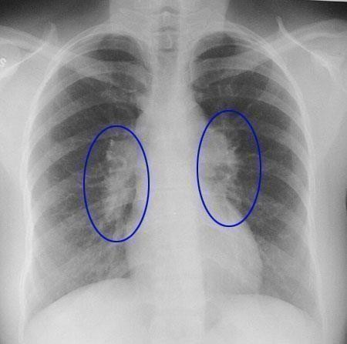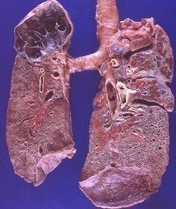

* 1. (b)

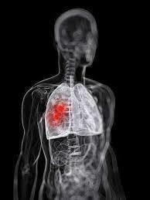

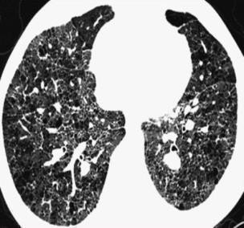

(c) (d)

Fig.1.3: (a) Sarcoidosis.(b) Sarcoidosis lung*.* (c) Sarcoidosis Lung in 3D*.* (d) Severe sarcoidosis.

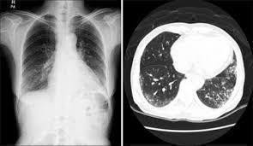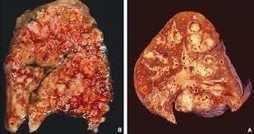

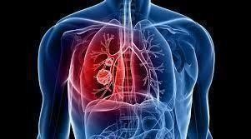(a) (b) (c)

**Fig**.1.4: (a) *IPF lung.* (b) *IPF 3D Lung.* (c) *IPF lung slice.*

The idiopathic lung severity and 3D structuring is shown in Fig 1.5(a), 1.5(b) &1.5(c). Idiopathic Pulmonary Fibrosis (IPF) is a type of lung disease that results in scarring (fibrosis) of the lungs for an unknown reason. Over time, the scarring gets worse and it becomes hard to take in a deep breath and the lungs cannot take in enough oxygen**.**

Detections Used in IPF (Idiopathic Pulmonary Fibrosis)

* Surgical lung biopsy and Bronchoscopy
* High-Resolution Computed Tomography (HRCT)
* Chestradiograph.

### 2.BIOMEDICAL IMAGE PROCESSING

* 1. **INTRODCTION**

Biomedical image processing has experienced dramatic expansion, and has been an interdisciplinary research field attracting expertise from applied mathematics, computer sciences, engineering, statistics, physics, biology and medicine. Computer-aided diagnostic processing has already become an important part of clinical routine. Accompanied by a rush of new development of high technology and use of various imaging modalities, more challenges arise; for example, how to process and analyze a significant volume of images so that high quality information can be produced for disease diagnoses and treatment. The principal objectives of this course are to provide an introduction to basic concepts and techniques for medical image processing and to promote interests for further study and research in medical imaging processing. We will introduce the Medical Image Processing and summarize related research work in this area and describe recent state-of-the-art techniques. The development in communication infrastructure in the global scale has made possible the concepts like telemedicine and robotic assisted surgery. These developments have rendered the role of image processing more critical and essential.

### STEPS OF IMAGEPROCESSING

The commonly used term “biomedical image processing” means the provision of digital image processing for biomedical sciences. In general, digital image processing covers four major areas shown in Fig2.1.

* + 1. **Image Formation:** Includes all the steps from capturing the image to forming a digital image matrix.
    2. **Image Visualization:** refers to all types of manipulation of this matrix, resulting in an optimized output of the image.
    3. **Image Analysis:** includes all the steps of processing, which are used for quantitative measurements as well as abstract interpretations of biomedical images. These steps require a priori knowledge on the nature and content of the images, which must be integrated into the algorithms on a high level of abstraction. Thus, the process of image analysis is very specific, and developed algorithms can be transferred rarely directly into other application domains.
    4. **Image Management:** sums up all techniques that provide the efficient storage, communication, transmission, archiving, and access (retrieval) of image data. Thus, the methods of telemedicine are also a part of the image management.

In contrast to image analysis, which is often referred to as high-level image processing, low level processing denotes manual or automatic techniques, which can be realized without a priori knowledge on the specific content of images. These types of algorithms have similar effects regardless of the content of the images. For example, histogram stretching of a radiograph improves the contrast as it does on any holiday photograph. Therefore, low-level processing methods are usually available with programs for image enhancement.

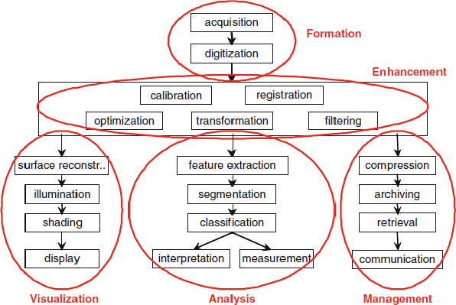

**Fig**.2.1: Modules of Image Processing

### BIOMEDICAL IMAGE PROCESSING

With these definitions, a particular problem in high-level processing of biomedical images is inherently apparent resulting from its complex nature, it is difficult to formulate medical prioriknowledgesuchthatitcanbeintegrateddirectlyandeasilyintoautomaticalgorithmsof image processing. In the literature, this is referred to as the semantic gap, which means the discrepancy between the cognitive interpretation of a diagnostic image by the physician (high level) and the simple structure of discrete pixels, which is used in computer programs to represent an image (low level). In the medical domain, there are three main aspects that hinder bridging this gap.

* + 1. **Heterogeneityofimages:**Medicalimagesdisplaylivingtissue,organs,orbodyparts.Evenif captured with the same modality following a standard, objects may vary remarkably not onlyfrompatienttopatient(inter-subjectvariation)butalsoamongthedifferentviewsofapatientand

similar views of the same patients at different times (intra-subject variation). In other words, biological structures are subject to both inter- and intra-individual alterability. Thus, universal formulation of a priori knowledge is impossible.

* + 1. **Unknown delineation of objects:** Frequently, biological structures cannot be separated from the background because the diagnostic or therapeutic relevance of the object is represented by the entire image. Even if definable objects are observed in biomedical images, their segmentation is problematic because the shape or borderline itself is represented fuzzily or only partly. Hence, medically related items often can be abstracted at most on the texture level.
    2. **Robustness of algorithms:** In addition to these inherent properties of medical images, which complicate their high-level processing, special requirements of reliability and robustness of medical procedures improves the complexity of image processing routines and algorithms. As a rule, automatic analysis of images in medicine should not provide wrong measurements. That means that images, which cannot be processed correctly, must be automatically classified as such, rejected and withdrawn from further processing. Consequently, all images that have not been rejected must be evaluated correctly.

### MEDICAL IMAGE FORMATION

Since the discovery of X-rays by Wilhelm Conrad Rontgen in 1895, medical images have become a major component of diagnostics, treatment planning and procedures, and follow-up studies. Furthermore, medical images are used for education, documentation, and research describing morphology as well as physical and biological functions in 1D, 2D, 3D, and even 4D image data (e.g., cardiac MRI, where up to eight volumes are acquired during a single heart cycle). Fig 2.2 emphasizes the differences in image characteristic with respect to the imaging modality. Obviously, an algorithm for delineation of an individual vertebra shape that works with one imaging modality will not be applicable directly to another modality.

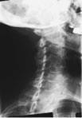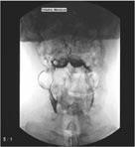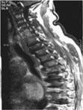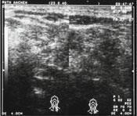

*X-RAY AXIALCT MRI ULTRASOUND*

**Fig**.2.2**:** Medical imaging modalities (the body region- cervical vertebra appears completely different when altering the imaging modality).

### COMPUTED TOMOGRAPHY (CT)

The initial use of Computed Tomography (CT) for applications in radiological diagnostics during the seventies sparked a revolution in the field of medical engineering. And even throughout the eighties, a CT examination lost little if any of its special and exclusive character. In the meantime, however, times have changed. Today computed tomography represents a perfectly natural and established technology which has advanced to become an indispensable and integral component of routine work in clinics and medical practices.

### History Of CT

The invention of computed tomography is considered to be the greatest innovation in the field of radiology since the discovery of X-rays. This cross-sectional imaging technique provided diagnostic radiology with better insight into the pathogenesis of the body, thereby increasing the chances of recovery. In1979, G.N. Hounsfield and A.M. Cormack were awarded the Nobel Prize in medicine for the invention of CT. Today, CT is one of the most important methods of radiological diagnosis. It delivers non-superimposed, cross-sectional images of the body, which can show smaller contrast differences than conventional X-ray images. This allows better visualization of specific differently structured soft-tissue regions, for example, which could otherwise not be visualized satisfactorily. Since the introduction of spiral CT in the ninty, computed tomography has seen constant succession of innovations. The development of slipring technology allowed for a continuously rotating gantry – the prerequisite for spiral CT. The first spiral CT scan new as a Siemens SOMATOMP system. Today this technology is widely used.

### Sequential CT

A cross-sectional image is produced by scanning a transverse slice of the body from different angular positions while the tube and detector rotate 360° around the patient with the

table being stationary. The image is reconstructed from the resulting ion data. If the patient moves during the acquisition, the data obtained from the different angular positions are no longer consistent. The image is degraded by motion artifacts and may be of limited diagnostic value. The tomographic technique is suitable only to a limited extent for the diagnosis of anatomical regions with automatism functions such as the heart or the lung.

### 2.5.3. Spiral CT

Spiral CT is often referred to as “volume scanning “. This implies a clear differentiation from conventionalCTandthetomographictechniqueusedthere.SpiralCTusesadifferentscanning

principle. Unlike in sequential CT, the patient on the table is moved continuously through the

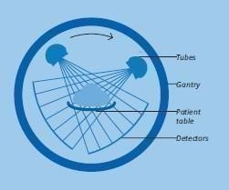

**Fig**.2.3: Sequential CT

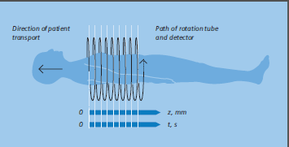scan field in the z direction while the gantry performs multiple 360° rotations in the same direction. The X-ray thus traces a spiral around the body and produces a data volume. This volume is created from a multitude of three-dimensional picture elements, i.e. voxels. The table movement in the z direction during the acquisition will naturally generate inconsistent sets of data, causing every image reconstructed directly from a volume data set to be degraded by artifacts. However, special reconstruction principles–inter-polation techniques which generate a planar set of data for each table position – produce artefact -free images. Thus, it is possible to reconstruct individual slices from a large data volume by overlapping reconstructions as often as required. Software applications enable the clinical use of spiral CT even for regions which are subject to involuntary movements.

**Fig**.2.4: Spiral CT

A CT system comprises several components. These basically include:

* The scanning unit, i.e. the gantry, with tube and detector system
* The patient tables
* The image processor for image reconstruction
* The console

The console represents the man-machine interface and is designed to be multi-functional.

It is the control unit for all examination procedures, and is also used to evaluate the examination results. To enhance the workflow, Siemens has developed a double console capable of performing both functions at the same time.

### WORKING OF CT SCANNER

The CT scanner consists of a couch upon which the patient is placed and a circular gantry through which the couch with patient is passed. Within the gantry is a rotating ring with an X-ray source opposed to a linear array of detectors.

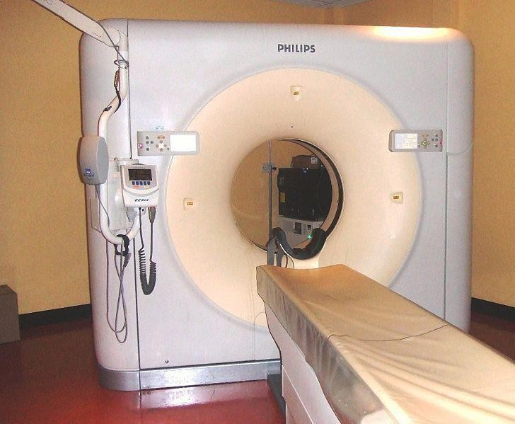

**Fig.**2.5: CT Scan Machine- A Philips 64 slice 'Brilliance' Scanner

in Fig2.5. The X-ray source is collimated so that the X- rays form a flat fan beam with a thickness determined by the user. During the acquisition of a "slice" of data, the source- detector ring is rotated around the patient. The raw output from the detector array is backed to form an image of the slice of the body. The couch is moved and then another slice is obtained.

The output from a CT scanner is a series of trans axial slices of the patient. Each slice represents a slab of the patients' body with a thickness set by the collimation for the slice (typically1-10mm). Foremost CT scanners each slab has 512 by 512 pixels. The size of a pixel can be varied within certain limits (generally 0.5to2mm). Generally, each slice is paced such that they are either overlapping or contiguous, though some protocols call

for gaps between the slices. Each pixel ideally represents the absorption characteristics of the small volume. Modern CT scanners can generally acquire one slice within 1 to 5 seconds.An entire study of a patient generally represents 30-40 slices, with a study time of 3-15 minutes. This is measured in Hounsfield Units(HU).

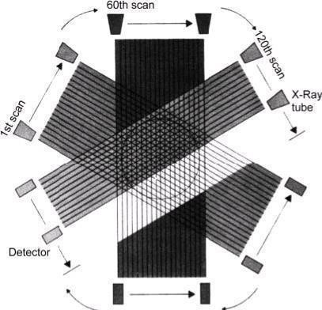

**Fig**.2.6: Various Scans at Different Angles

X-ray slice data is generated using an X-ray source that rotates around the object; X-ray sensors are positioned on the opposite side of the circle from the X-ray source. Fig 2.6 shows various scans at different angles.

The earliest sensors were scintillation detectors, with photomultiplier tubes excited by (typically) sodium iodide crystals. Modern detectors use the ionization principle and are filled with low-pressure Xenon gas. Many data scans are progressively taken as the object is gradually passed through the gantry. CT produces a volume of data which can be manipulated, through a process known as windowing, in order to demonstrate various structures based on their ability to block the X-ray beam. Although historically the images generated were in the axial or transverse plane (orthogonal to the long axis of the body), modern scanners allow this volume of data to be reformatted in various planes or even as volumetric (3D) representations of structures.

A CT scanner uses a series of X-ray beams to build up images of the body in slices.

Unlike an X-ray, which sends one beam of radiation through the body, a CT scanner emits a succession of narrow beams as it moves through an arc. This produces a very detailed image

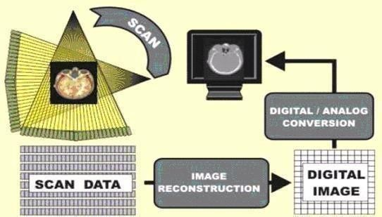

**Fig**.2.7: Conversion of Scanned Data into Medical Image

The X-ray detector within a CT scanner can see hundreds of different levels of density, including tissues within solid organs such as the liver. This information is then sent to a computer, which builds up a cross-sectional image of the body and displays it on the screen. Fig 2.7 sums up the steps taken to for an image from scanned data Depending on the part of the body being examined, a contrast dye may be used to make some tissues show up more clearly under X-ray. For scans of the abdomen, you might be given a drink containing barium. This is known as a barium meal, and shows up white on the scan as it moves through the digestive tract. Contrast dyes may also be given as an enema or injected into the bloodstream, depending on the part of your body that is to be scanned. 2D & 3D imaging is achieved by rotating an x-ray emitter around the patient, and measuring the intensity of transmitted rays from different angles.

A relatively new technique, a spiral CT has improved the speed and accuracy of the scan for many diseases. The X-ray beam takes a continuous spiral path during scanning, gathering continuous data with no gaps between images. A spiral scan can usually be obtained while holding your breath, which allows a scan of the chest to be done in a fewseconds.

### WHAT DOES A CT IMAGESHOW?

The CT image does not show these μ values directly, but the CT numbers according to Hounsfield:

CT number =1000 (μ – μ water) / μ water

CT numbers are measured in HU=Hounsfield units. The CT number of water and a iris defined as 0 HU and –1000 HU respectively; this scale has no limit in the positive range of values. Medical scanners typically work in a range of –1024 HU to +3071HU.

### WINDOWING

In the CT image, density values are represented as grayscale values. However, since the human eye can discern only approx. 80 gray scale values, not all possible density values can be displayed in discernible shades of gray. For this reason, the density range of diagnostic relevance is assigned the whole range of discernible gray values. This process is called windowing. To set the window, it is first defined which CT number the central grayscale value is to be assigned to. By setting the window width, it is then defined which CT numbers above and below the central gray value can still be discriminated by varying shades of gray, with black representing tissue of the lowest density and white representing tissue of the highest density.

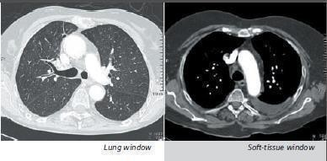

**Fig**.2.8: Windowing Process

The first obvious results of any CT examination are the axial cross-sectional images. Since these images are already available in digital form on a storage medium, they can be processed immediately by the processor. The evaluations of geometrical parameters such as distance, area, angle and volume as well as density measurements are part of clinical routine today. The tissue density is determined using the CT number averaged over a defined evaluation area, the so-called Region of Interest (ROI). Geometrical parameters can be defined more accurately than in conventional radiography, since the problems of superimposition and distortion do not exist in CT.

### CT IN GENERAL CLINICAL USE

The use of spiral CT has significantly shortened scan times compared to sequential CT. This is of great advantage when examining patients who, due to the nature of their illness, are unable to cooperate. Motion artifacts caused by different respiratory conditions during the acquisition are reduced considerably, because in spiral CT the entire volume is scanned faster and without gaps. Multiple scans due to breathing during the acquisition are no longer necessary. The patient dose is therefore reduced.

### Advantages of Spiral CT in Clinical Use

* Complete coverage of organs in a single respiratory position
* Short scan times (resulting in fewer motion artifacts and a lower contrast medium requirement)
* Additional diagnostic information due to improved resolution (thinner slices) and3D visualization in routine operation
* Special cost-effective applications based on spiral CT

### CT-Angiography (CTA)

CT-Angiography (CTA) enables the display of vascular structures aided by injections of contrast medium. The introduction of the multi slice scanner has made it possible to display the entire vascular system with maximum contrast enhancement in extremely short scan times.

Image post processing enables good display of the entire vascular system. Even small vascular exits and origins (branches) and embolisms or dissection membranes can be displayed. The physician can retrospectively select any ion and generate three-dimensional images, e.g. for surgical planning.

### CT Scanning Advantages

Elimination of Super Position Soft Tissue Differentiation Multiplanar Reformatted Imaging

Reduction of Need for Exploratory Surgery

### Disadvantages

* + - 1. Radiation Dosage
      2. Potential for unnecessary use
      3. Allergic reactions to contrast agents
      4. Misconceptions of radiologists

### Common Medical Applications

1. Screening of lungs of a smoker
2. Virtual colonoscopy
3. Cardiac screening
4. Appendicitis Diagnosis

### Challenges in Bio Medical Image Processing

There are number of specific challenges in medical image processing. They are;

* Image enhancement and restoration.
* Automated and accurate segmentation of features of interest.
* Automated and accurate registration and fusion of multimodality images.
* Classification of image features, mainly characterization and typing of structures.
* Quantitativemeasurementofimagefeaturesandaninterpretationofthemeasurements.
* Development of integrated systems for the clinical sector.

### DICOM

DICOM stands for Digital Imaging and Communications in Medicine and represents years of effort to create the most universal and fundamental standard in digital medical imaging. As such, it provides all the necessary tools for the diagnostically accurate representation and processing of medical imaging data. Moreover, contrary to popular belief, DICOM is not just an image or file format. It is an all-encompassing data transfer, storage, and display protocol built and designed to cover all functional aspects of digital medical imaging (which is why many view DICOM as a set of standards, rather than a single standard). Without a doubt, DICOM truly governs practical digital medicine. Another important acronym that seemingly all DICOM companies plug into their names is PACS (Picture Archiving and Communication Systems). PACS are medical systems (consisting of necessary hardware and software) designed and used to run digital medical imaging. They comprise digital image acquisition devices (modalities – such as Computed Tomography (CT) scanners, or ultrasound), digital image archives (where the acquired images are stored), and work stations (where radiologists view the images). Of course, PACS take the model to a much more complex level as shown in Fig 2.9. PACS are directly related to DICOM. Their functionality is DICOM- driven, which ensures their interoperability. For that reason, any PACS device or software comes with its own DICOMC on formance Statement, which is a very important document explaining the extent to which the device supports the DICOM standard. In essence, PACS bring the DICOM standard to life. Image acquisition devices

(modalities) store images on a digital archive. From there images are accessed by radiologists at the view stations.

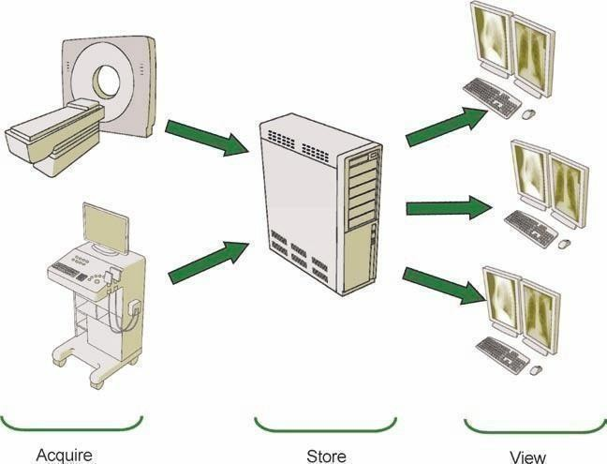

**Fig**.2.9: Major Picture Archiving and Communication System (PACS) components*.*

One can hardly imagine modern-day digital medicine without DICOM and PACS. The DICOM standard conceived over 20 years ago plays an integral role in the digital medicine evolution, ensuring the highest diagnostic standards and the best performance.

DICOM has truly shaped the landscape of contemporary medicine by providing:

1. A universal standard of digital medicine. All current, digital image-acquisition devices produce DICOM images and communicate through DICOM networks. Current medical workflow is implicitly controlled by a multitude of DICOM rules, which will be reviewed in this book.
2. Excellent image quality. For example, DICOM supports up to 65,536 (16 bits) shades of gray for monochrome image display, thus capturing the slightest nuances in medical imaging. In comparison, converting DICOM images into JPEGs or bitmaps (BMP), always limited to 256 shades of gray, often makes them impractical for diagnostic reading. DICOM takes advantage of the most current and advanced digital image representation techniques to provide the utmost diagnostic image equality.
3. Full support for numerous image-acquisition parameters and different data types. Not only does DICOM store the images, butital so records amultitude of other image-related parameters such as patient 3D position, physical sizes of objects in the image, slice thickness, image exposure parameters, and so on. These data immensely enrich the informational content of DICOM images, and facilitate the processing and interpretation of the image data in various ways (for example, creating 3D images from several sequences of two-dimensional CTslices).
4. Complete encoding of medical data. DICOM files and messages use more than 2000 standardized attributes (DICOM data dictionary) to convey various medical data from patient

name to image color depth, to current patient diagnosis. These data are often essential for accurate diagnostics, and capture all aspects of the current radiology.

1. Clarity in describing digital imaging devices and their functionality – the backbone of any medical imaging. DICOM defines medical device functionality in very precise and device- independent terms. Working with medical devices through their DICOM interfaces becomes a very straightforward process, leaving little room for errors.

### 2.10.1 DICOM INRADIOLOGY

The DICOM (Digital Imaging and Communications in Medicine) standard is the backbone of modern image display, equivalent only to film in the pre-digital era. Since the inception of this standard some 20 years ago, it has become the driving force behind the entire imaging workflow. DICOM truly controls all parts of digital image acquisition, transfer and interpretation, and many radiologists and other imaging specialists and users may not realize to what extent their work relies on DICOM capabilities.

Dependence on DICOM is more in nowadays. DICOM is used to collect the original medical images. This process is much more complex compared to X-Ray film, but is also more accurate and complete. DICOM has the advantage that it can send, distribute, and store images, irrespective of machine, manufacturer, or modality.

DICOM controls proper image display, and without DICOM it won’t have any image post processing-beit simple multi plan are construction, or more advanced per fusion analysis, virtual colonoscopy, volume segmentation, or computer-aided diagnosis. DICOM provides much of the ease and flexibility in work. As digital medicine becomes increasingly complex and imaging globalize, knowledge of DICOM basics for any healthcare professional becomes crucial. When thinking about the next picture archiving and communication system upgrade, or a new teleradiology, or simply about installing a new digital modality, DICOM should be the crucial reference.

Standard, DICOM-based workflow is the only way to build a robust and efficient radiology practice. It is also the only way to integrate your medical imaging into a complete enterprise-wide electronic patient record solution.

## 3.SEGMENTATION

### IMAGE SEGMENTATION

Segmentation is the first and foremost step in image analysis. The objective of segmentation process is to partition an image into distinct, semantically meaningful entities by defining boundaries between features and objects in an image based on some constraint, or homogeneity predicate. Specifically, the segmentation problem is defined as sufficiently partitioning an image into non-overlapping regions. The level to which this subdivision is carried is influenced by the type of the problem being solved. The segmentation end when the object of interest in the application has been isolated. The consequence of dividing an image from its background defines attached areas which record the entire image region, or determines the outline or boundaries obtained from the image. The segmentation renders the image in such a form where it is easy and meaningful to analyze an image. Image segmentation is very specifically used for identifying objects and boundaries in an image. Image segmentation algorithms assign a label to every pixel in an image region, such that all the pixels with the same label share certain similar visual characteristics. The segmentation process results in a set of segments that together combine into the entire image, or a set of contours or edges extracted from the image. Each of the pixels in a region has some similarity with respect to some characteristic feature or computed attribute, such as colour, intensity or texture while adjacent regions have significantly different characteristics.

Most of the segmentation algorithms are based on one of the two properties of gray level values namely Discontinuity and Similarity. While using the property of discontinuity, the image is portioned based on abrupt changes in gray level. This type of approach is used primarily for detection of isolated points and for detection of lines and edges in an image. In the second category the principal approaches are based on thresholding, region growing, region splitting and merging. The accuracy and judging certainty in classifying any lung abnormality lies on relevant segmentation technique. Image segmentation is used to describe boundaries or objects in pictures. Medical image segmentation accomplishes visual characteristics of image with same objects belonging to those intensities as a group.

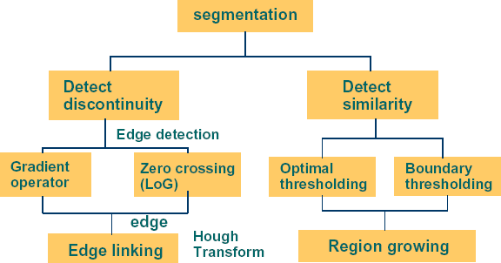

**Fig**.3.1: Types of segmentation and their principle

### Edge-Based Segmentation

Edge based segmentation algorithms identify the edges by using the first and second derivatives producing outlines which borders the segments. The derivatives are obtained by the application of different masks to the image. The mask is a small an matrix proposed by Sobel, Laplace, Kirsch, Prewitt and various others. Each of these masks has their own output characteristics and selection of a particular mask depends largely on the type and nature of the input image. The Edge-based segmentation techniques are capable of detecting fine edges in the image, but they typically enhance noise in the image. Edge based segmentation techniques require a huge processing power, which is about ‘n’ times the image size for each mask of nan, but ital ways requires a finite amount of time. On the other hand, image clustering, a technique of region-based segmentation for certain type of images sometimes does not terminate.

### Region-Based Segmentation

Region based segmentation algorithms work by grouping similar valued neighbouring pixels of image. Several techniques that fall under this category include thresholding (that include local, global and adaptive), clustering, region growing, region merging and splitting. Thresholding is implemented by grouping intensity values of the pixels by a set of predefined criterion values as borders. Intensity values of the pixels that lie between the border values according to the predefined criteria are assigned the same intensity value, thus combining into the same region or segment.

Clustering algorithms work by randomly selecting a certain number of pixels as seed

points called starting points, and then grouping other pixels that have intensity values near specified by a predetermined tolerance level at the starting points. The average values of these segmented groups are then calculated and those values are used as new starting points. This process of calculating new starting point by averaging the intensities in the groups is repeated until there no new starting points are there to be further selected.

Region growing is a bottom-up approach which is based on randomly selecting a certain group of pixels as seed or starting points, and then selecting adjacent pixels in the neighbourhood that have intensity values near to the seed points. These pixels satisfying the criteria are then grouped into a region and the region growing process expanded further until no more pixels in the image region meet the predefined criterion.

Regionsplittingandmergingisatop-downapproachinwhichtheimagesaresubdivided in to set of arbitrary disjointed subregions. These regions are further merged and/or split to meet the predefined segmentation criteria.

The steps on which the above process can be implemented are as follows

1. Split the entire image region into four disjointed quadrant region ArkifP(Ark)=FALSE
2. Merge any two adjacent regions Riand Rajif P (RiU Raj)=TRUE
3. Stop the process when all the pixels are segmented into their corresponding regions and further merging or splitting of the regions impossible.

### DETECTION OF DISCONTINUITIES

The most common type of gray level discontinuities in digital image is points, lines, and edges. These discontinuities can be identified by applying a mask through the image. The sum of products of the coefficients with the gray levels is computed for the region encompasses by the mask.

|  |  |  |
| --- | --- | --- |
| **w1** | **w2** | **w3** |
| **w4** | **w5** | **w6** |
| **w7** | **w8** | **w9** |

|  |  |  |
| --- | --- | --- |
| **z1** | **z2** | **z3** |
| **z4** | **z5** | **z6** |
| **z7** | **z8** | **z9** |

(a) Mask Coefficients (b) Gray level values

**Fig**.3.2: 3×3 general mask and gray level values

That is, with reference to the response of the mask at any point in the image is given by

R=w1z1+w2z2+....................+w9z9 (3.1)

Where ziis the gray level of the pixel associated with mask coefficient wi. As usual, the response R of the mask is defined with respect to its center location.

### Edge Detection for Image Segmentation

The changes of grey tones in the image are exploited by the edge detection transform to obtain edge images. This ensures that edge image is obtained without encountering any changes in physical qualities of the main image.

An edge represents boundaries and hence represents an important fundamental problem in image processing. Edges define a rapid and random change in the intensity values of an image. Important structural information is preserved and unnecessary data can be eliminated and filtered by using the edge detection techniques. The different methods for edge detection can primarily be grouped in to Gradient and Laplacian categories. The gradient method identifies edges by looking for maximum and minimum values in the first derivative of the image while Laplacian method searches for zero crossings in second derivative of the image. Since the edge is characterized by one-dimensional shape of a ramp its location can be highlighted by calculating its derivatives of the shape of a ramp and after that by calculating the derivative of the image we can obtain highlighted edge location. The following signal, with jump in intensity is shown below that characterizes the edge. The gradient of the above signal is the first derivative with respect to t. The following Fig shows the one-dimensional gradient profile.

It can be clearly identified that the derivative points to maximum located at the center of edge in the original signal. This way of identification of edges is grouped under “gradient filter” family of edge detection that includes Sobel Method. Edge location is declared if the pixel locations gradient values exceed some threshold. Since the edges have high intensity values when compared to neighboring pixels, the edges can be identified by comparing the pixel value with the threshold. The edges can also be identified by locating the zeros in the second derivative. This is made possible because when the first derivative is at maximum

derivative of the signal is shown below

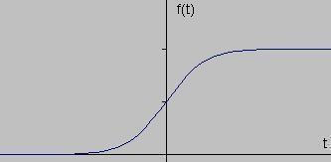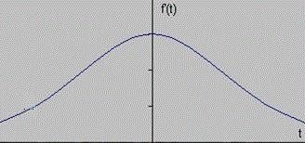

* (b)

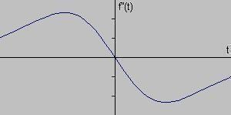

(c)

**Fig.**3.3 (a): Gray level profile of an image. (b) First order derivative of the profile. (c)Second order derivative of the profile*.*

### CLASSIFICATION OF EDGE DETECTORS

Edge detectors are classified in to five categories as follows:

* + **Gradient edge detectors:** Which contains classical operators and uses first directional derivative operation. It includes algorithms such as: Sobel (1970)**,** Prewitt (1970), Kirsch (1971), Robinson (1977), Frei-Chen (1977), Deatsch and Fram (1978), Nevatia and babu (1980), Ikonomopoulos (1982), Davies (1986), Kitchen and Malin (1989), Hancock and Kittler (1990), Woodhall and Linquist (1998) and Young-won and Udpa (1999).
    - **Zero crossing:** Which uses second derivative and includes Laplacian operator and second directional derivative.
    - **Laplacian of Gaussian (LoG):** This was invented by Marr and Hildreth (1980) who combined Gaussian filtering with the Laplacian. This algorithm is not used frequently in machine vision. Those who continued his way were Berzins (1984), Shoh, Soodand Jain (1986), Huertas and Medioni(1986).
    - **Gaussian Edge Detectors:** Along the edge this is symmetric and noise reduction is achieved by smoothing the image. The significant operators here are Canny and ISEF (Shen-Castan). Both the operators convolve the image with the derivative of Gaussian function.
    - **Colored Edge Detectors:** Which are divided into three categories output Fusion methods, Multi-dimensional gradient methods and vector methods
    - **Morphological Edge Detectors:** Mathematical morphology is a methodology which was initiated in the late 1960s by G Matheron and J Serra at the Fontainebleau School of Mines in France.

### MORPHOLOGICAL OPERATIONS

Mathematical Morphology (MM) is a nonlinear subbranch of the signal processing field which deals with the application of set theory concepts to the domain of image analysis. In general, the study of shapes and structures is referred as Morphology. Morphological operators are nonlinear transformations, which modify geometric properties of images. The operators employ a structuring element of particular shape and size to transform the image through a series of iterations.

Mathematical morphology can be used to process and analyze the images. Morphology provides an alternative approach to digital image processing based on the concept of shape stemmed from set theory, and not on conventional mathematical modelling and analysis. In Morphological theory, images to be processed are treated as sets, and morphological transformations which are nonlinear are derived from Minkowski addition and subtraction is defined to extract import ant features in images. Classical edge detectors performance degrades with noise; hence morphological edge detector has been studied. Mathematical morphology is developed from set theory. It was introduced by Matheron as a technique for analyzing the geometric structures. This concept was extended to image analysis by Serra. Morphological

operations are defined by set arithmetic. Therefore, the image which is to be processed according to mathematical morphology theory must be first changed into set. Mathematical morphology operations use structuring element, which is characteristic of certain structure and feature, to measure the shape of image and then carry out image processing. Based on set theory, mathematical morphology is the operation which transforms from one set to another. The aim of this transformation is to search the special set structure of original set. The transformed set includes the information of the special set structure and the transformation is realized by special structuring element. Therefore, the result is correlative to some characteristics of structuring element.

### Basic Operations In Morphology

The basic mathematical morphological operators are dilation and erosion and the other morphological operations are the synthesization of the two basic operations. In the following some basic mathematical morphological operators of gray-scale images are introduced. Let *F*(*x*, *y*) denote a gray-scale two-dimensional image, *B* denote structuring element. Dilation of a gray-scale image *F*(*x*, *y*) by a gray-scale structuring element *B*(*s*, *t*) denoted by (*F*⨁*B*)(*x*,*y*)=max{*F*(*x*-*s*,*y-t*)+*B*(*s*,*t*)} (3.3)

Erosion of a gray-scale image *F*(*x*, *y*) by a gray-scale structuring element *B*(*s*, *t*) is denoted by

(*F* Θ*B*)(*x*, *y*) = min{*F*(*x* + *s*, *y* +*t*)-*B*(*s*,*t*)} (3.4)

Dilation is the maximum pixels set union when structuring element overrides image, while erosion is the minimum pixels set union when image is overlapped by structuring element. Opening and closing of gray-scale image *F*(*x*, *y*) by gray-scale structuring element *B*(*s*, *t*) are denoted respectively by

*F* ο *B*=(*F*Ө*B*)⨁*B* (3.5)

*F●B*=(*F*⨁*B*)Θ*B* (3.6)

Opening operation is the *dual* of closing operation, *i.e.,* opening the foreground pixels in an image with a particular structuring element is equivalent to closing the back ground pixels with the same element in the same image. Similarly closing operation is the dual of opening operation, *i.e.,* closing the foreground pixels in an image with a particular structuring element, is equivalent to closing the background with the same element.

Erosion is a transformation of shrinking, which decreases the gray-scale value of the image, while dilation is a transformation of expanding, which increases the gray-scale value of the image. But both of them are sensitive to the image edge whose gray-scale value changes obviously. Erosion filters the inner image while dilation filters the outer image.

Openings erosion followed by dilation and closing is dilation followed by erosion. Opening generally smoothes the contour of an image, breaks narrow gaps. As opposed to opening, closing tends to fuse narrow breaks, eliminates small holes, and fills gaps in the contours. Therefore, morphological operation is used to detect image edge, and at the same time, denoise the image.

Among all morphological operators, the opening and closing operator are fundamental. They can be used for image description as well as image manipulation (with noise filtering as a special case). Given their sensibility to noise, in recent literature, several proposals were published to improve their robustness. The majority aim to improve their performance as a filter.

Morphological edge detection algorithms usually select an appropriate structuring element to process an image and by making use of the basic morphological theory that include operations such as erosion, dilation, opening and closing, and synthesization operations to get a clear edge image. In the process, the synthesized modes of the operations and the feature of structuring element decide the result of the process image. In detail, the synthesized mode of the operations reflects the relation between the processed image and origin image, and the selection of structuring element decides the effect and precision and the result. Therefore, the keys of morphological operations can be generalized for the design of morphological filter structure and the selection of structuring element. In medical image edge detection, it is needed to select appropriate structuring element by texture features of the image. And the size, shape and direction of structuring element must been considered roundly. Usually, except for special demand, select structuring element by3×3square.

By the operation features of morphology, erosion and dilation operations satisfy:

*F*Θ*B*⊆*F*⊆*F*⨁*B* (3.7)

Opening and closing operations satisfy:

*F*ο*B*⊆*F*⊆*F●B* (3.8)

What is discussed above shows that dilation and closing operations can expand the processed image while erosion and opening operations can shrink the processed image. But the processed image is similar to the original image.

### Morphological gradient

A transformation is applied to convert the original image in to gradient image representing the strength of each edge pixel. A threshold can then be applied to classify each

pixel in to edge point or nonedged point *Multiscale edge detector.* To increase therobustness

to noise a multi scale gradient algorithm is used. This refers to the use of structuring elements of different sizes thereby rendering it insensitive to noise.

The multi scale edge detector applicable to find the gradient of the image based on morphological operations is

𝑀𝐺(𝑓)=1∑𝑛〖[((𝑓𝑏)−(f𝑏))〗𝑏−1] (3.9)

𝑛 𝑖=1 𝑖 𝑖 𝑖

Where, parameter *n* denotes scale and *bi*denotes the square structuring elements group with sizes (2i+1)×(2i+1) pixels. The gradient of an image is shown in Fig 3.4.

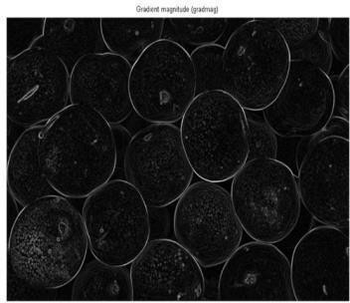

**Fig**.3.4: Gradient image

### ADVANTAGES AND DISADVANTAGES OF EDGE DETECTORS

It is always important to choose edge detectors that fit best to the application. In this respect some advantages and disadvantages of algorithms within the context of classification are presented.

**Table**.3.1: Advantages and Disadvantages of edge detectors.

|  |  |  |
| --- | --- | --- |
| **Operator** | **Advantages** | **Disadvantages** |
| **Classical (Sobel,**  **Prewitt, Kirsch etc.)** | Simplicity, Detection of edges and their orientations. | Sensitivity to  noise, inaccurate. |
| **Zero Crossing (Laplacian, Second directional derivative)** | Detection of edges and their orientations,  Having fixed characteristics in all directions. | Re responding to some of the existing edges,  Sensitivity to noise. |
| **Laplacian of Gaussian (LoG) (Marr- Hildreth)** | Finding the correct places of edges, Testing wider area around the pixel. | Malfunctioning at corners, curves and in areas where the gray level intensity function varies.  Edge orientation cannot be  found as Laplacian filter is used. |
| **Gaussian (Canny, Shen-Castan)** | Using probability for finding error rate, Localization and response, signal to noise ratio improvement, Better detection especially in noisy environment. | Complex computations, False zero crossing, Time consuming. |
| **Colored Edge Detectors** | Accurate, More efficient in object recognition. | Complicated,  Complex computations. |
| **Morphology Edge Detector** | Powerful tool that eliminate undesirable features without affecting desirable ones. | Insensitive to noise. Also to extract various sharpness details of the edges. |

### MORPHOLOGICAL RECONSTRUCTION

The process of Morphological reconstruction conceptually can be thought as repeated dilations applied to an image, where the resulting image called the *marker image*, until the contour of the marker image fits exactly under another image, called the *mask image*. In this process of reconstruction, the intensity peaks in the marker image "spreadout" or “dilate”.

to lie underneath the mask as shown in the Fig. When there is no change in the image due further dilation operation, the process is ceased, and there constructed image is the final dilated image. The effect of successive dilations of the marker is shown in Fig3.5.

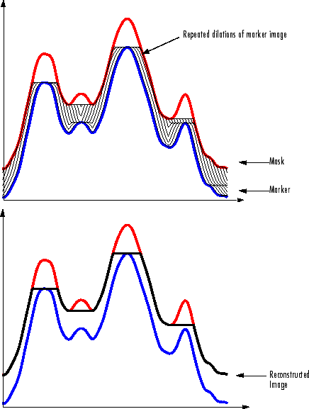

**Fig**.3.5: Successive Dilations of Marker, Constrained by Mask.

Morphologybasedreconstructionsincludemorphologicaldilationandthereconstruction process is based on two images, marker and mask, rather than single image and a structuring element. Similarly, it uses the concept of connectivity rather than the structuring element and the process repeats itself until there are no changes in the image.

### MEDICAL IMAGE SEGMENTATION

Edge detection is one of the most commonly used operations in image analysis. An edge is defined by a discontinuity in grey level values. In other words, edge is the boundary between an object and the background. The shape of the edges in images depends on many parameters: the geometrical and optical properties of the object, the illumination conditions, and the noise level in the image. Detection applied to Medical images is an important work for object recognition of most of the human organs such as lungs, brain and ribs, and it is an essential pre-processing step in segmentation of medical image and analysis.

The edge detection process decides the result of final processed image. In real world applications, a medical image acquired contain important features like object boundaries and object shadows and sometimes noise. The processing to be applied depends on the content which one desires to extract. Therefore, a frequent problem in low-level vision arises to eliminate and suppress the noise and other unrelated detail from the degraded image, without degrading the regions of interest.

### METHODOLOGY ANDIMPLEMENTATION

* 1. **REQUIREMENTS**

The program was developed in MATLAB R2013b in Windows operating system. The standard functions of MATLAB and MATLAB Image Processing Toolbox are used. Because of large amount of data processed, a computer with at least 1GB of RAM is required. Speed of the processor is not crucial.

#### METHODOLOGY

Step1: Creating a Graphical User Interface (GUI) layout design in MATLAB .

Step2: Collecting the DICOM Lung CT images.

Step3: Develop gradient images using appropriate edge detection function. 6TH CHAPTER. Step4: Mark the Foreground Objects using morphological operation.

Step5: Compute Background Markers.

Step6: Compute the Watershed Transform of the Segmentation Function.

Step7: Extraction of lung region.

* + 1. Use Structuring Elements (Square, Disk) to probe an image with a small shape or template.
    2. Perform Morphological operations like - opening by reconstruction.
    3. Perform closing by reconstruction.
    4. Compliment the input image.
    5. Reconstruction is performed to extract the original image.

Step8: Display of Sarcoidosis ILD patterns-ROI that includes lung region.

Step9: Comparison of extracted ROIs from original and noise added original images and computing Peak- Signal to Noise ratio and Correlation Co-efficient between original ROI and noise added ROI Step 11: Any discontinuities present are filled, so that perfect region properties like boundaries and their respective centroids are maintained which helps to evaluate the area of the abnormality accurately

Step 10: Taking the area as a parameter to detect the abnormalities, all the possible abnormalities are annotated with areas. This quantification can be taken as secondary opinion to understand the progress of the Sarcoidosis ILD pattern. Based on this the diagnosis and prognosis of the disease can be performed.

### GUIDE

MATLAB Graphical User Interface development environment provides a set of tools for creating graphical user interfaces (GUIs). These tools greatly simplify the process of designing and building GUIs. You can use the GUIDE tools to Lay out the GUI Using the GUIDE Layout Editor, you can lay out a GUI easily by clicking and dragging GUI components such as panels, buttons, text fields, sliders, menus, and so on into the layout area. GUIDE automatically generates an M-file that controls how the GUI operates. The M-file initializes the GUI and contains a framework for all the GUI callbacks, the commands that are executed when a user clicks a GUI component. Using the M-file editor, you can add code to the callbacks to perform the functions.

To start GUIDE, enter guide at the MATLAB prompt. This displays the GUIDE Quick Start dialog, as shown in the following figure.

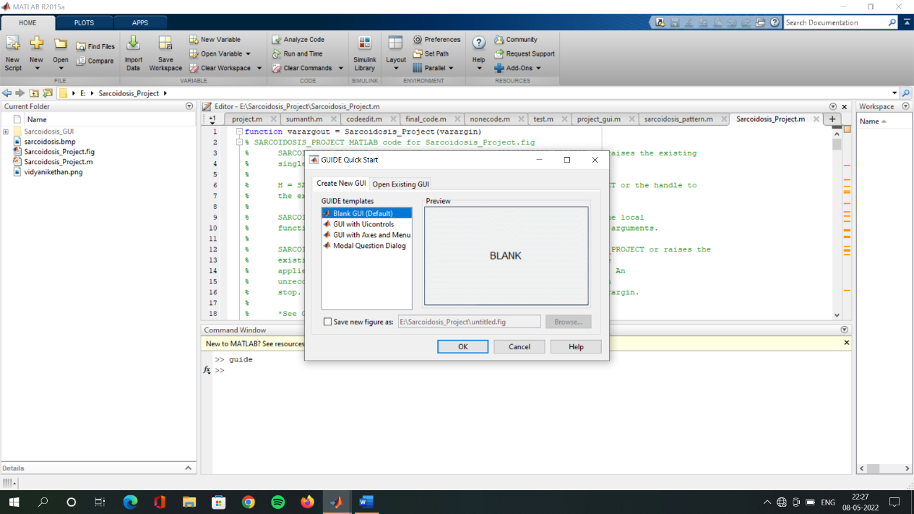

**Fig**.6.1: GUIDE Quick Start dialog

From the Quick Start dialog, you can create a new GUI from one of the GUIDE templates. Prebuilt GUIs that you can modify for your own purposes open an existing GUI.

Once you have selected one of these options, clicking OK opens the GUI in the Layout Editor

### The Layout Editor

When you open a GUI in GUIDE, it is displayed in the Layout Editor, which is the control panel for all of the GUIDE tools. The figure-6.2 shows the Layout Editor with a blank GUI template. You can lay out your GUI by dragging components, such as push buttons, pop-up menus, or axes,

from the component palette, at the left side of the Layout Editor, into the layout area. You can also use the Layout Editor to set basic properties of the GUIcomponents.

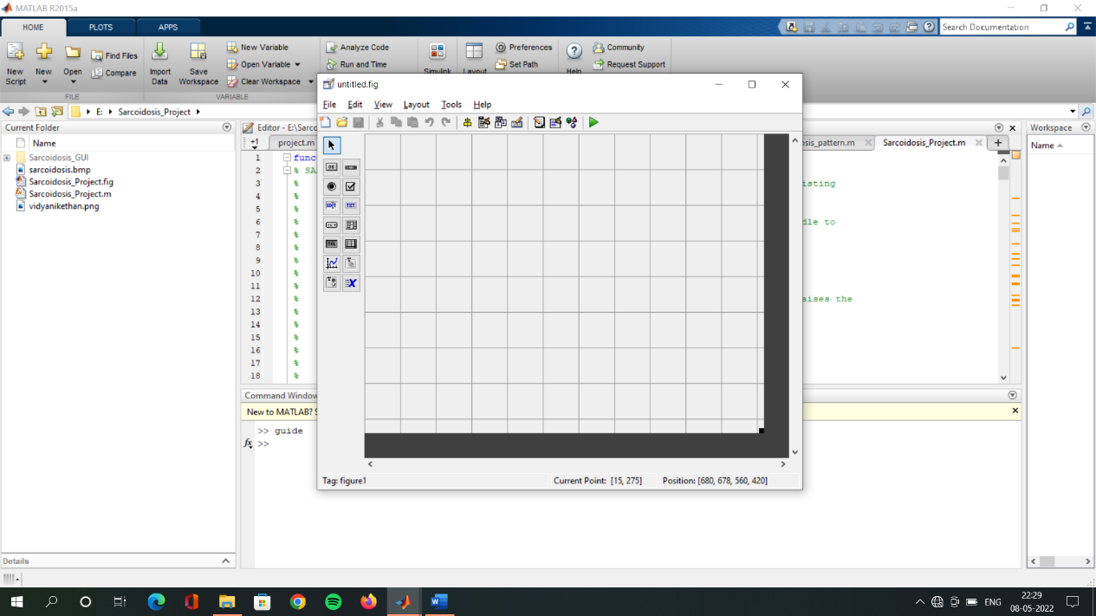

### Static Text

**Fig**.6.2: GUI Layout Editor

MATLAB returns the value of the edit text String property as a character string. If you want users to enter numeric values, you must convert the characters to numbers. You can do this using the str2double command, which converts strings to doubles. If the user enters nonnumeric characters, str2double returns NaN. You can use the following code in the edit text callback. It gets the value of the String property and converts it to a double. It then checks whether the converted value is NaN (isnan), indicating the user entered a nonnumeric character and displays an error dialog (errordlg). As we can see in Fig: 6.3 Static text.

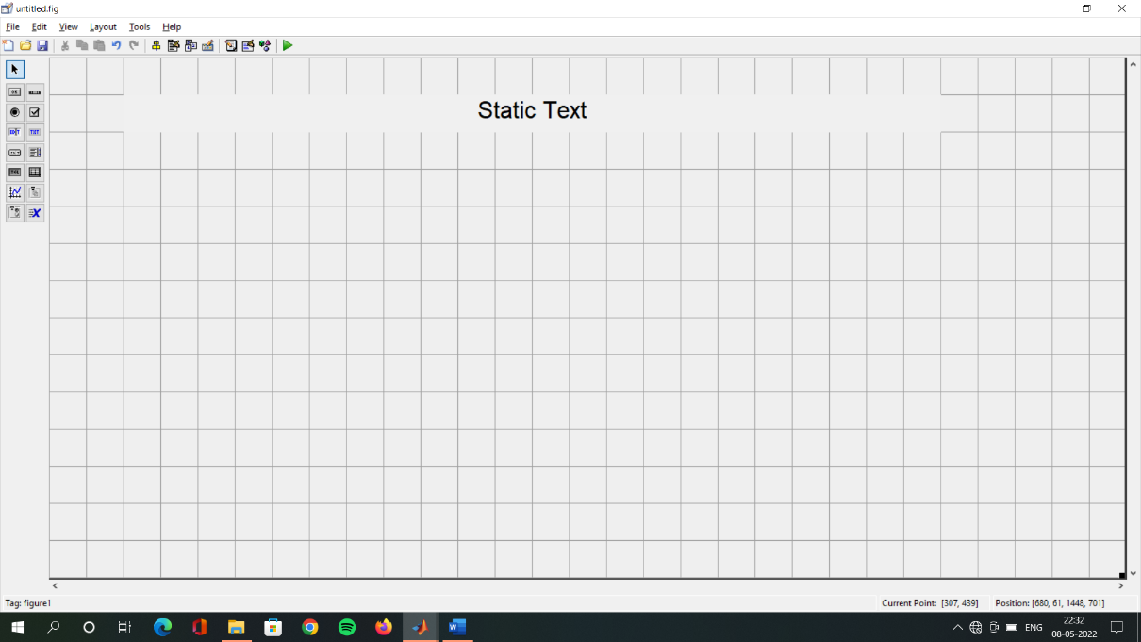

**Fig**.6.3: Static Text

### Axes

Axes enable your GUI to display graphics (e.g., graphs and images). Like all graphics objects, axes have properties that you can set to control many aspects of its behaviour and appearance. See Axes Properties" in the MATLAB Graphics documentation for general information on axes object.

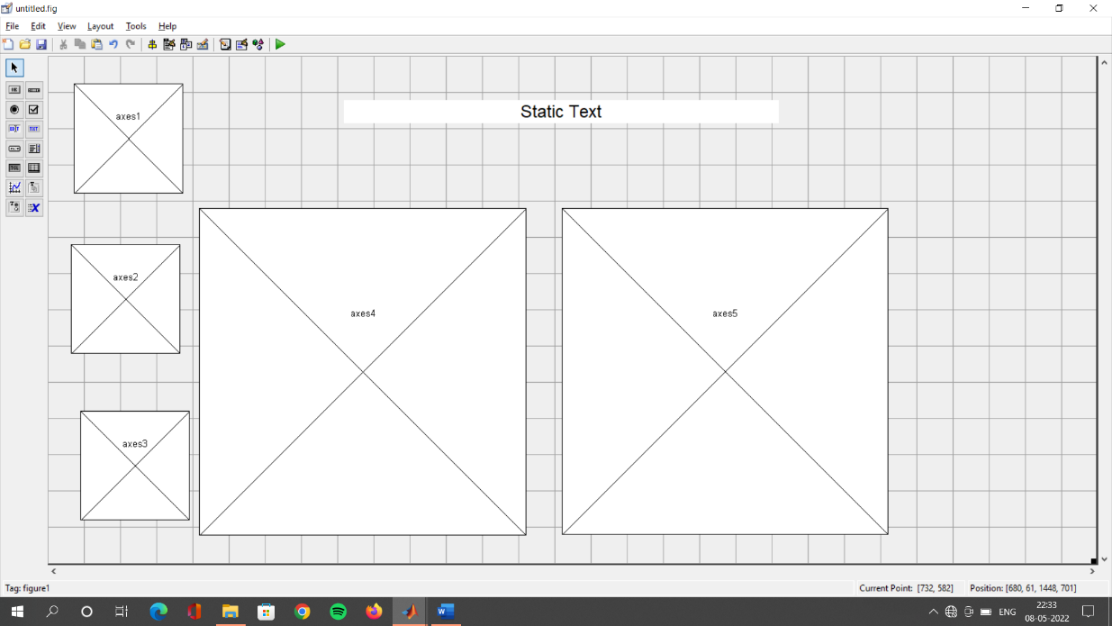

**Fig**.6.4: Axes

### Push Button

* + Firstly use GUIDE, then place a pushbutton and place a static text as we can see in Fig 6.5Adding push button
  + Double click on the text label and set a visible property to off in the property inspector.
  + Save the GUI and then go to the editor and go to the pushbutton callback function.
  + Finally, put below lines of code.

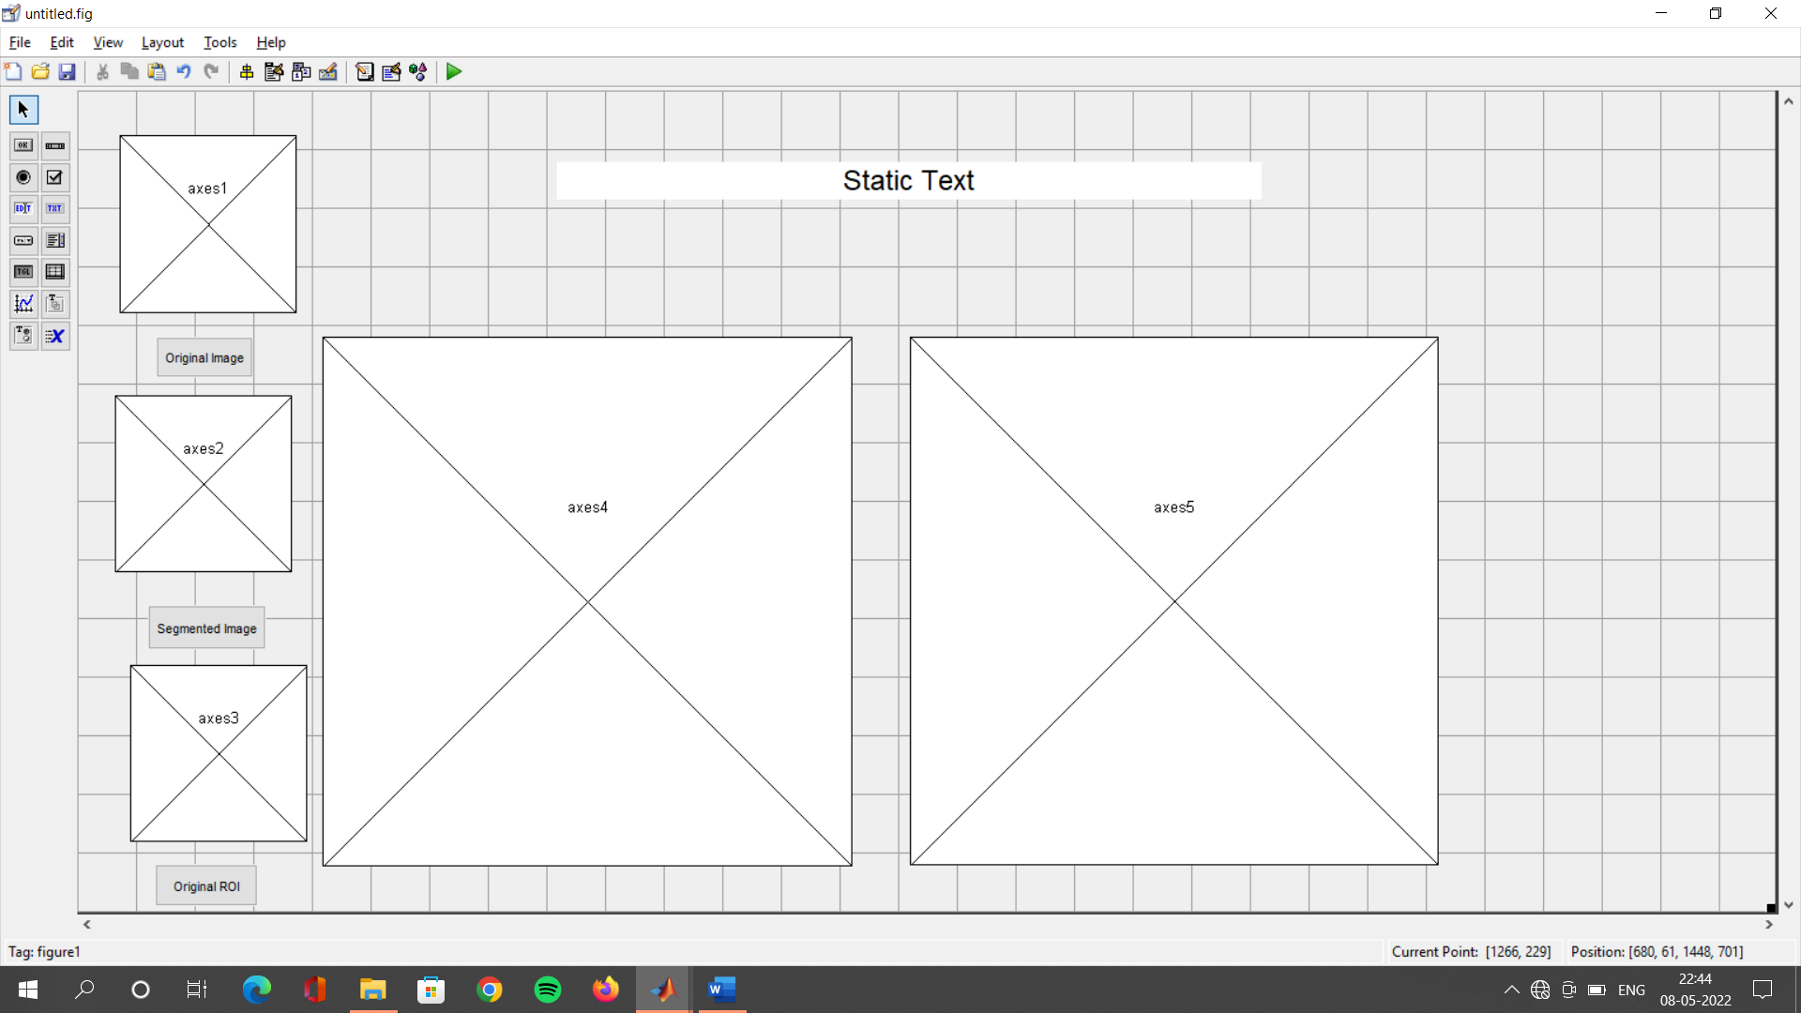

**Fig**.6.5: Adding Push Button

### DEVELOPMENT OF GRAPHICAL USER INTERFACE

An important requirement for clinical diagnosis and treatment is a platform for medical image processing technique that is more flexible and accurate. A multifunctional GUI that performs interactive image processing of medical images is developed. The tool is a MATLAB based Graphical User Interface that performs multiple image processing functions for processing of images using human data in different formats. GUI window (Figure.6.4) with functions: Load image, Process, and Measures which includes different image processing functional tools.

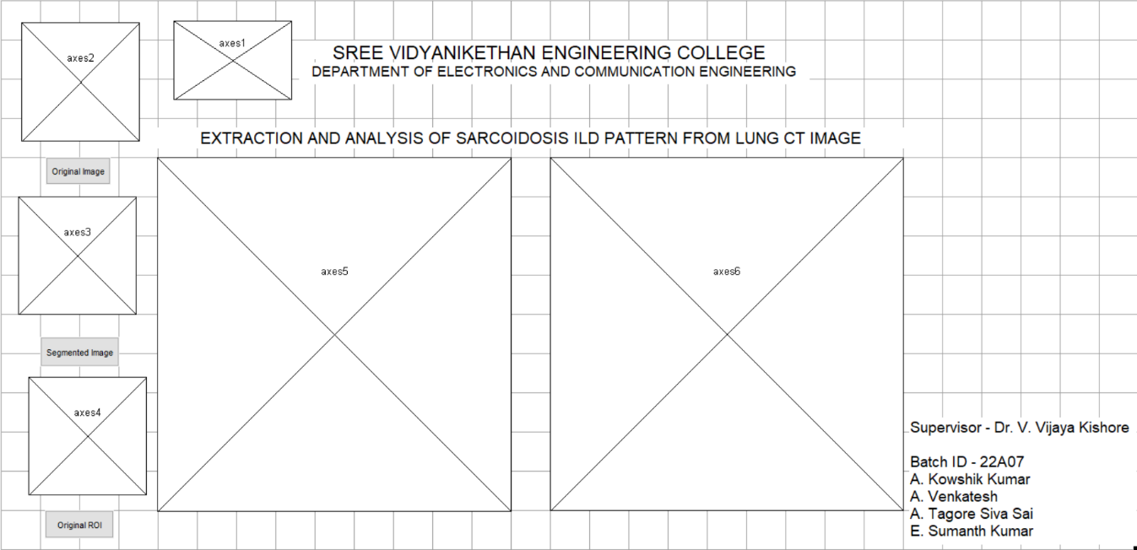

**Fig**.6.5: GUI Interface

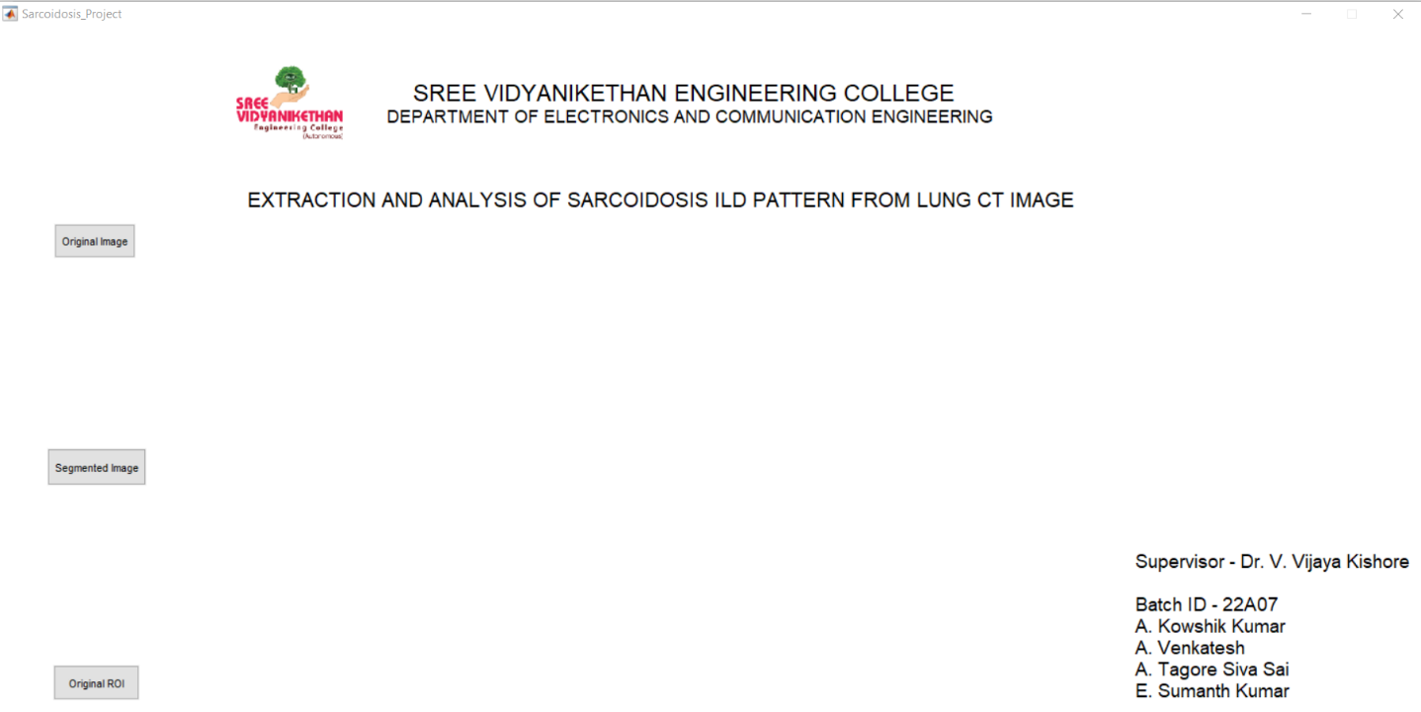

**Fig**.6.7: GUI Interface Template

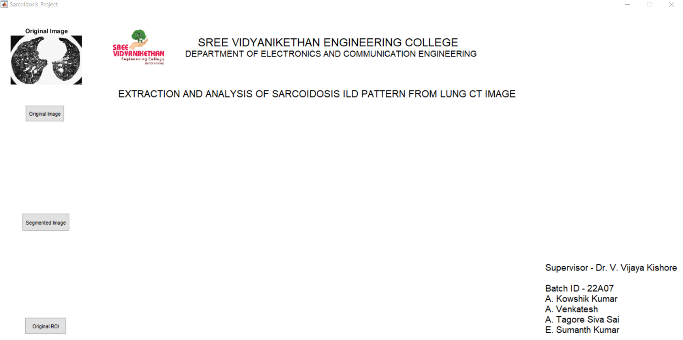

**Fig.**6.8: Original Image

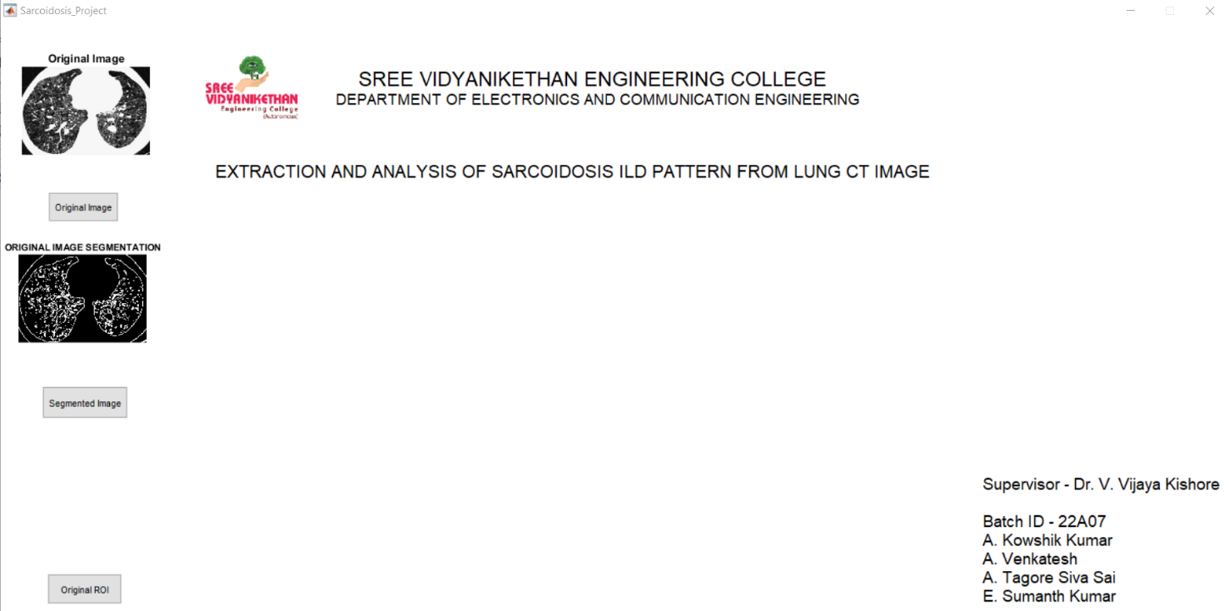

**Fig** 6.9: Original Image Segmentation

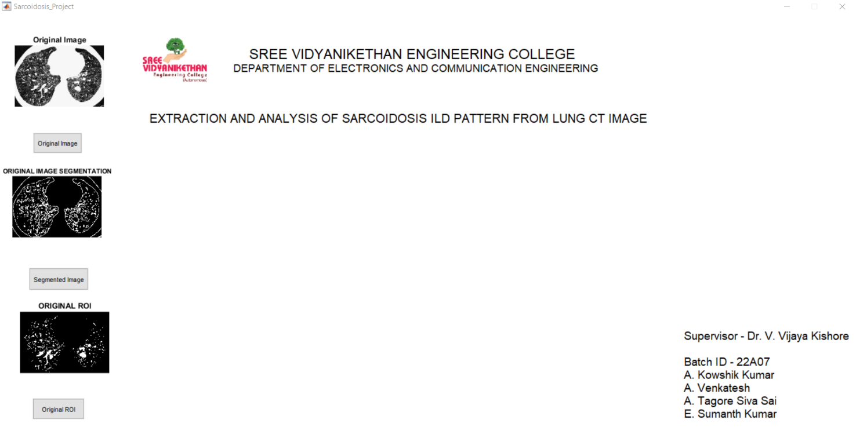

**Fig** 6.10: Original ROI

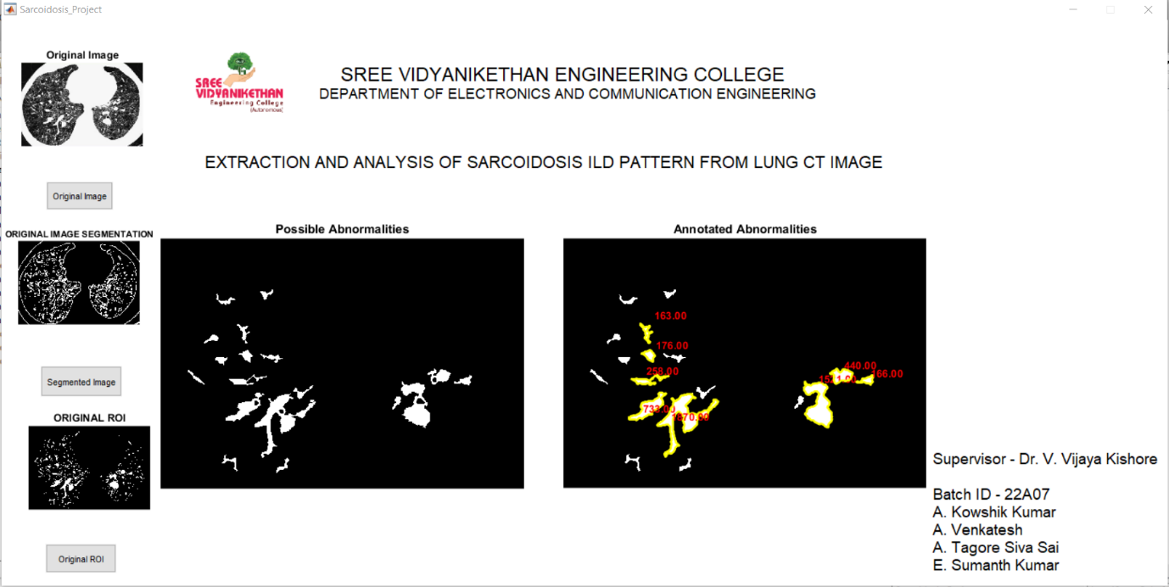

**Fig** 6.11: Abnormalities

### RESULTS AND DISCUSSIONS

Medical image segmentation is an important step for most successive image analysis tasks. In automatic detection of lung nodules, the goal of the lung segmentation is required to separate the regions corresponding to the lungs. CT is considered to be the most accurate imaging modality for early detection and diagnosis of lung cancer. Manipulation of volumetric CT data sets may improve a radiologist’s ability to detect small nodules. With the integration of computers in medicine, a need arises to develop computer assisted tools for the optimized detection and quantitative evaluation of the largest number of small nodules identified by volumetric chest CT in both diagnosis and screening studies. A method is proposed that performs extraction of the lung region for nodule detection based on morphological operations watershed, and wavelet transforms. This method can be used as a tool for automatic detection of lung nodules from DICOM-CT scan image. The steps of the method are described in detail next.

#### Lung Extraction

The goal of the lung extraction is to separate the voxels corresponding to lung tissue from the voxels corresponding to the surrounding anatomical structures. Watershed transform is a region-based approach. Generally, on the gradient image the watershed transform is applied, where the boundaries of the catchment basins are located at high gradient points. A well-known drawback in watershed segmentation is over-segmentation. Since, every regional minimum, even if tiny and insignificant, forms its own catchment basin, over-segmentation occurs. By using marker-based watershed transform, we can decrease the regional minima and bound them within the region of interest to prevent over-segmentation. There are several techniques to define markers and choosing a technique is highly dependent on the application. Before the watershed transform is applied, the gradient image must be obtained first. The Sobel masking operator is applied on the original pulmonary CT image Fig 6.1(a) in both horizontal and vertical directions to create the gradient image as shown in Fig 6.1(b). The lung region is marked as internal and external markers. The internal markers are the connected components of the pixels with almost the same intensity values, whose external boundary pixel values are all greater than n. The value of n is a gray level value, which specifies the approximate gray level value for non-body pixels in CT images. Since, in pulmonary CT images the air will appear with a mean intensity of approximately -1000 Hounsfield Units (HU), lung region will be in the range of-1000to-400HU and the chest wall, blood and bone will be much dense and well above -400 HU. In order to specify the internal

markers, the regions with pixel values lower than -400 HU are selected.

#### Background Removal

The background of the CT image is almost black (lower than -400HU), so, it makes an erroneous regional minimum. There is a high degree of similarity between the gray levels of Lungs and the image background. So is removed bye liminating the objects, which are attached to the border of the binary image. After eliminating the background, the small objects in the markers which are caused by theveins should be eliminated. The close morphological operator is used to obtain the compliment to eliminate the small objects and a complete internal marker is obtained.

#### External Marker

Lung border is located in the neighborhood area of the internal marker. To bind this area an external marker is required. The internal marker is dilated with two circular structuring elements with different ratios. By subtracting the results, external marker is specified.

#### Regional Minima Impose

Regional minima will be placed only in the marked area of the gradient image. This is required to compute the waters headlines in the region of interest. Minima imposition procedure, which utilizes morphological reconstruction, is used to place regional minima only within the area of the union of the two markers.

#### Watershed Transform

Watershed transform of the obtained image finds the watershed lines corresponding to the most significant edges between the markers. These watershed lines are the borders of the lung regions Since during this transform a dam is created between the two lung regions to prevent merging, the thin wall between the attached left and right lung is also extracted.

#### Filling and Lung Extraction

In some CT images, the segmented lung region excludes dense structures, such as juxta pleural nodules and hilar vessels. To include these structures the rolling bar filter is used. The segmented lung border is superimposed on the original image and the closed morphological operator is applied.

#### Wavelet Transform

In the proposed approach, discrete wavelet transform is used to decompose the segmented image into directional sub-images. Discrete wavelets correspond multiresolution approximations of the images. Biorthogonal wavelets are used to obtain the intensity

approximation, horizontal, vertical, and diagonal directions. The discrete wavelet transform of image f(x,y) of size M and N can be written as

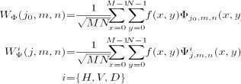 (.1)



(7.2)

Φ(*x,y*) is the scaling function and Ψ*H*(*x,y*), Ψ*V*(*x,y*), and Ψ*D*(*x,y*) are three two- dimensional wavelets, which are the products of one-dimensional Φ and corresponding wavelet Ψ. is a superscript that identifies the directional wavelets.

The methodology is implemented on the DICOM lung CT image. This image is given as input and the corresponding ILD patterns, directional details and extracted lesions are obtained. Segmented ROI and the directional details of sarcoidosis pattern is shown in Fig7.1. The final lesion details of sarcoidosis pattern extracted from the lung ROI are shown in Fig7.2.

The performance of the proposed method is evaluated in the presence of noise. The purpose of this evaluation is to estimate the noise reduction feature of the proposed method. This evaluation will help to understand the distortion added to the CT image if it is transferred over a network where there is a prone to noise. Four types of noise: Salt and pepper noise, Speckle noise, Poisson noise, Gaussian noise are added to the original CT lung image are shown in Fig.7.7 ROIs and lesion details are extracted using the proposed method from each of the noise added image. A set of intermediate images for extracting ROI from Poisson noise added image while processing is shown inFig.7.4.

The evaluation of the proposed method in noisy environment is performed for four ROI images and compared with the original extracted ROI – Sarcoidosis pattern. For the evaluation two parameters are considered, Peak Signal – to – Noise ratio and Correlation Co- efficient. The values are tabulatedinTable.7.1.

It is observed that proposed method can be reduce the effect of poisson noise comparedto other noise added based on correlation coefficient andpsnr.

|  |  |  |
| --- | --- | --- |
|  |  |  |
| *Original lung CT image* | *Gradient of image* | *Image open* |
|  |  |  |
| *Image reconstruct* | *LOC* | *Image compliment* |
|  |  |  |
| *Foreground Image* | *Foreground superimposed* | *Background image* |
|  |  |  |
| *Markers and boundaries*  *super imposed on original image* | *Lrgb* | *Lrgb superimposed*  *transparently on original image* |

**Fig**.7.1: Resultant intermediate images of Sarcoidosis pattern extraction

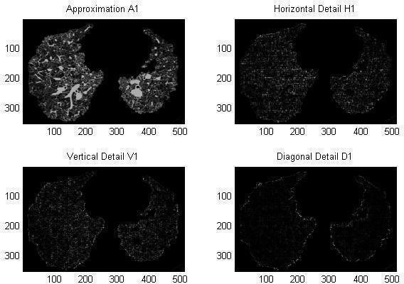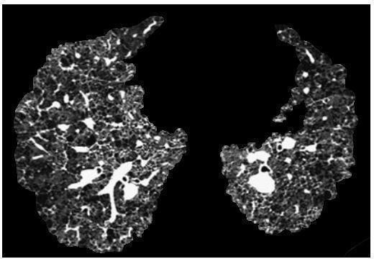

**Fig.**7.2: Segmented ROI and directional details of Sarcoidosis Pattern

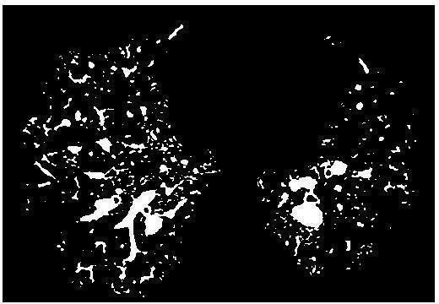

**Fig.**7.3: lesion details (sarcoidosis pattern detected by ROI) of Sarcoidosis Pattern

|  |  |
| --- | --- |
|  |  |
| *Original Image Segmentation* | *Original ROI* |
|  |  |
| *Possible Abnormalities* | *Annotated Abnormalities* |

**Fig**.7.4: Resultant Images

**CONCLUSIONS AND FUTURE SCOPE**

#### CONCLUSION

Majority of the pulmonary diseases and their identification rely on geometric progression of lung spaces. Some of the physicians expressed the inadequacy in image parts which are known as (ROI)Region Of Interest. Researchers conver seat focusing on ROI coding to guarantee the use of multiple and randomly shaped ROI’s in image, because depicting the importance of ROI is affected by the background regions that exhibit various levels of quality, brightness, and shapes. In this project, a GUI is designed to perform morphology-based segmentation is used to extract Sarcoidosis ILD pattern is developed and implemented. Morphology based region of interest segmentation is implemented to extract various lung patterns by lung ROI segmentation that delineates the diseased part. The results provide a high-quality visual screening of extracted patterns of different ILD patterns such as malignant nodules, and sarcoidosis pattern. The resulting images provide valuable information about the structures and their growth over a duration of examination which helps the clinicians for early diagnosis and prognosis. In addition to this, the proposed method is evaluated in the presence of noise to estimate the noise reducing capability of the method for a particular noise. The peak signal to noise ratio and correlation coefficient are computed for extracted Sarcoidosis patterns from original and noise added images. It is observed that the proposed method has reduced the effect of Poisson noise compared to Salt and pepper noise, Speckle noise, and Gaussian noise. This is identified by high values of PSNR and Correlation Co- efficient for Poisson noise compared to other noise.

#### FUTURE SCOPE

Assessing the abnormality, growth progression and descriptive characteristics can be taken as future work. Further the procedure can been hanced to assess the extracted patterns by changing the structuring elements for morphology-based ROI segmentation and also for different ILD pattern.

### REFERENCES

1. Felix Ritter, Tobias Boskamp, André Homeyer, Hendrik Laue, Michael Schwier, Florian Link, and Heinz-Otto Peitgen, “Medical Image Analysis”, Proceedings of CVPR’96 IEEE PULSE, pp 2154-2287 November/December2011.
2. Kushal Kr. Roy, Amit Phadikar,”Automated Medical Image Segmentation: A Survey”, Proc. of Int. Conf. onComputing, Communication & Manufacturing2014.
3. Ping-Lin Chang and Wei-Guang Teng, “Exploiting the Self-Organizing Map for Medical Image Segmentation”, IEEE International Symposium on Computer-Based Medical Systems (CBMS'07)0-7695-2905-4/07.
4. V.Vijaya Kishore, R V S. Satyanarayana, “Computer-Aided Diagnosis Tool for Honeycomb Detection by Using Morphology And Wavelet Transform In Lung CT Images”, IFRSA’s International Journal Of Computing|Vol2|issue 2|April2012.
5. V. Kalpana, Prof GK Rajini, “Segmentation of Lung Lesion Nodules Using DICOM Either Structuring Elements and Noise-A Comparative Study”, IEEE digital explore library DOI:10.1109/UPCON.2016.7894661.
6. V. Kalpana, Dr S Varadarajan and T. Milindapurna, “Performance Evaluation of DICOM Lung ROI with Different Sizes of Morphological Structuring Elements and Noise”, International journal of applied engineering research, vol. 10, no.6 pp.4991- 4996, 2015.
7. T.M. Deseronto, “Biomedical Image Processing”, Biological and Medical Physics, Biomedical Engineering, DOI: 10.1007/978-3-642-15816-2 1, Springer-Verlag Berlin Heidelberg,2011.
8. http: ://en.wikipedia.org/wiki/computed tomography.
9. http:://imaginis.com/CT-scan/history.asp
10. Ian D. Robertson, Travis Several, “Hospital, Radiology, And Picture Archiving And Communication Systems”, Clin Tech in Small Amin Pac, 2007;22:138-144.
11. <http://www.chemeurope.com/en/encyclopedia/Computed_tomography.html.>
12. <http://www.medical.siemens.com/siemens/zh_CN/gg_ct_FBAs/files/brochures/CT_H>[i](http://www.medical.siemens.com/siemens/zh_CN/gg_ct_FBAs/files/brochures/CT_History_and_Technology.pdf) [story_and_Technology.pdf](http://www.medical.siemens.com/siemens/zh_CN/gg_ct_FBAs/files/brochures/CT_History_and_Technology.pdf)
13. Oleg S. Piyankh, “Digital Imaging and Communications in Medicine (DICOM)- A PracticalIntroductionandSurvivalGuide”,©2008Springer-VerlagBerlinHeidelberg.
14. Gonzalez. R.C, Woods R. E, "Digital Image Processing" 2/E, Prentice HallPublisher, 2002.
15. WilliamK.Pratt,“DigitalimageProcessing”,JohnWiley-IntercedencePublication,3rd Edition, 2011
16. Mohsen Sharif, Mahmoud Fathy et al, “A Classified and Comparative Study ofEdge Detection Algorithms”, Proceedings of the International Conference on Informations